# **Lab 2**

By: Qadeer Hussain

Student ID: C00270632

Table of Contents

**Lab 2** 1

**Publishing and exposing ports** 2

**Publishing Ports** 2

**Publishing to ephemeral ports** 3

**Publishing all ports** 4

**Try it out** 5

**Overriding container defaults** 8

**Overriding the network ports** 8

**Setting environmental variables** 8

**Restrciting the container to consume the resources** 8

**Try it out** 10

**Persisting container data** 16

**Container volumes** 16

**Managing volumes** 17

**Try it out** 17

**Sharing local files with containers** 22

**Volume versus bind mounts** 22

**Sharing files between a host and container** 22

**File permissions for Docker access to host files** 23

**Try it out** 23

**Multi-container applications** 28

**Try it out** 28

## **Publishing and exposing ports**

### **Publishing Ports**

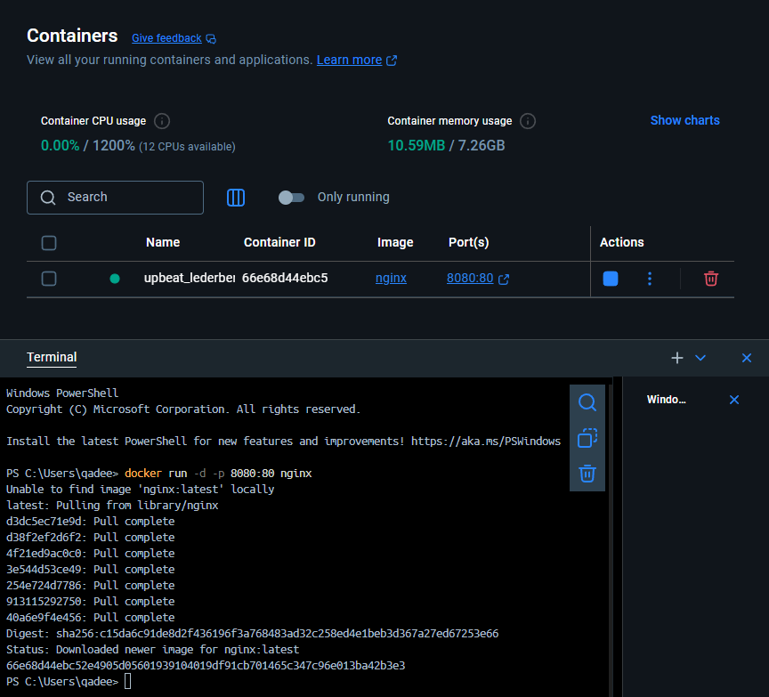

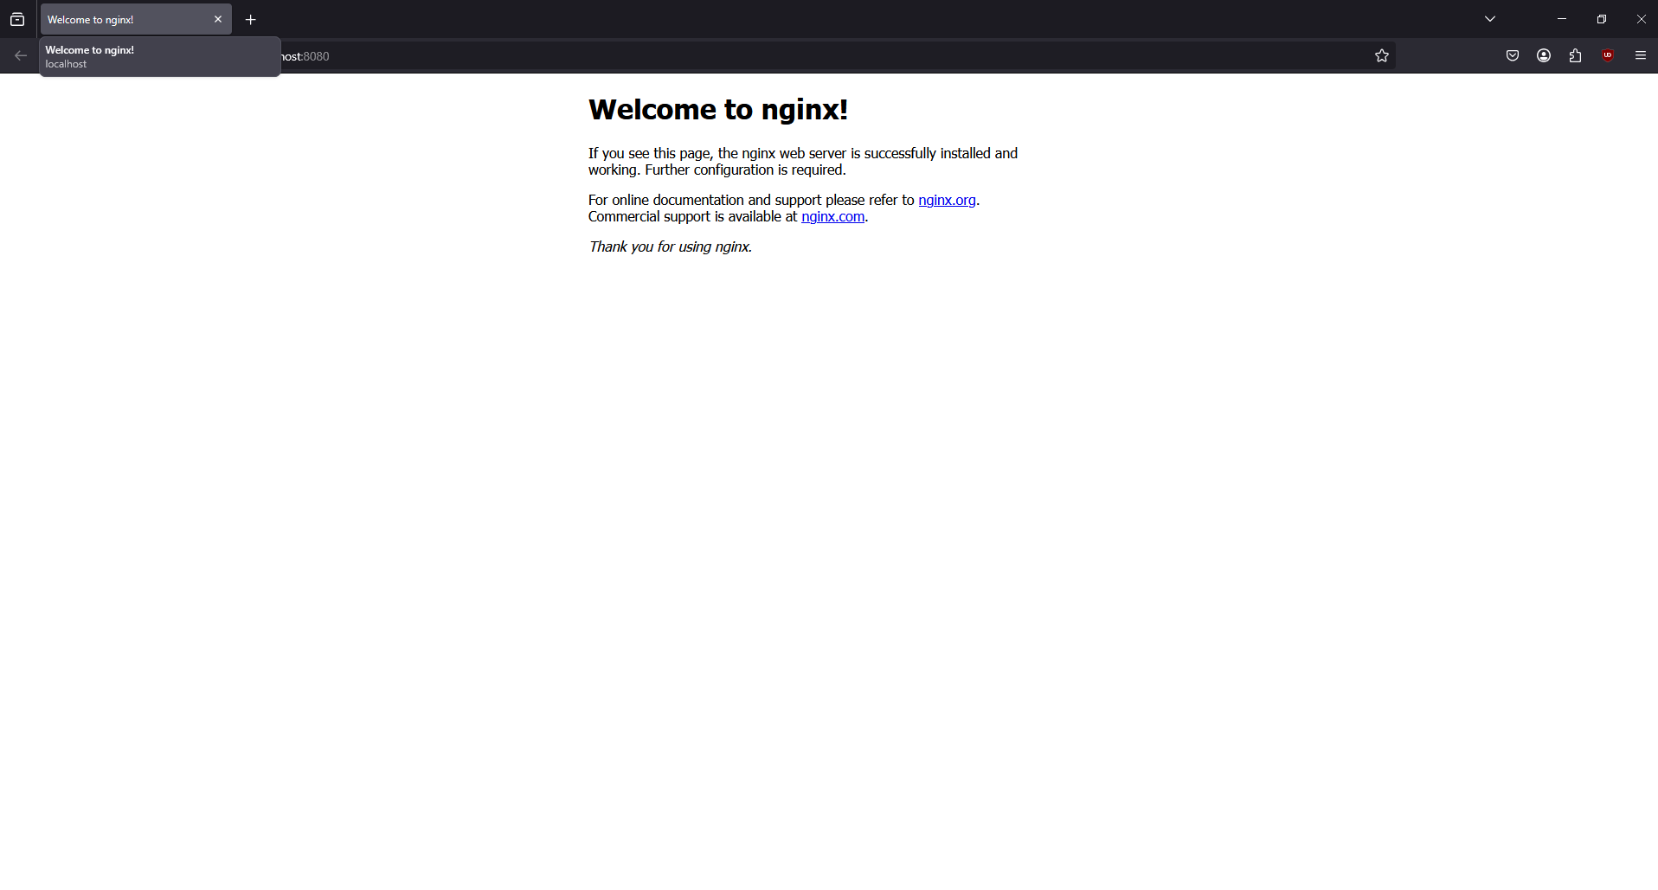

### [**Publishing**](https://docs.docker.com/get-started/docker-concepts/running-containers/publishing-ports/#publishing-to-ephemeral-ports) **to ephemeral ports**

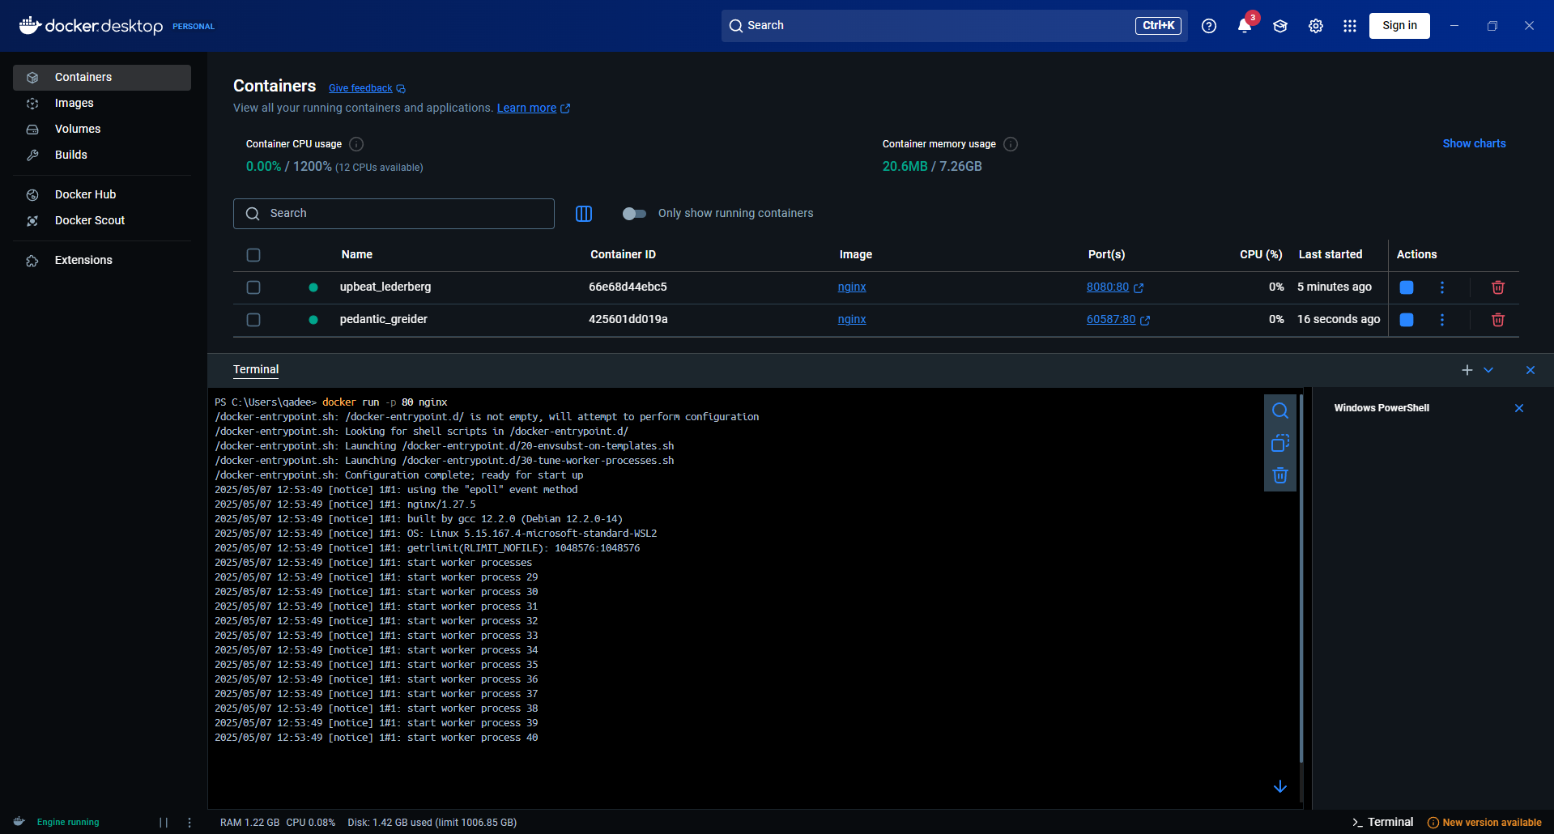

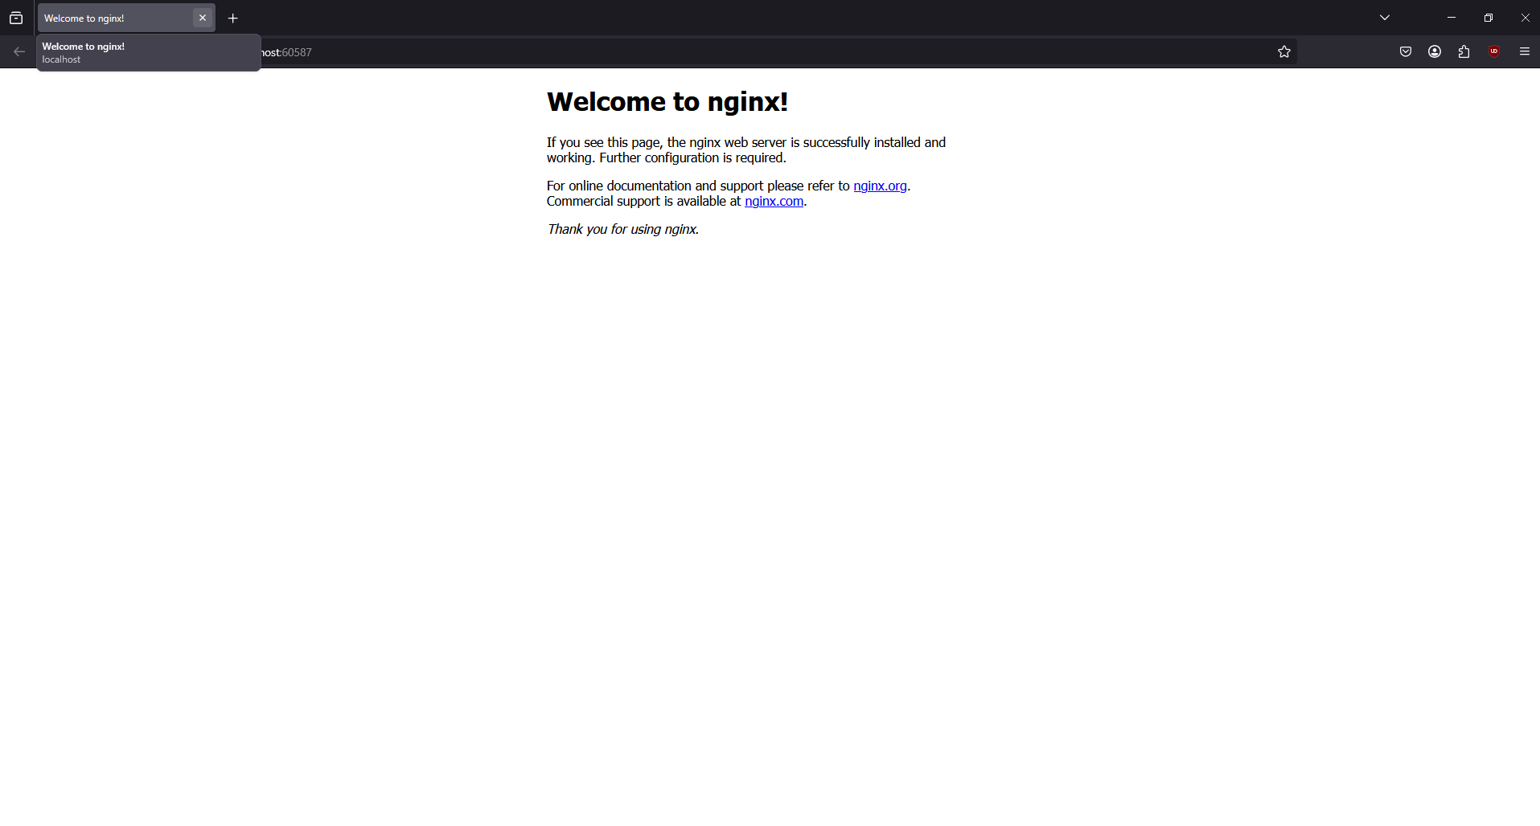

### **Publishing all ports**

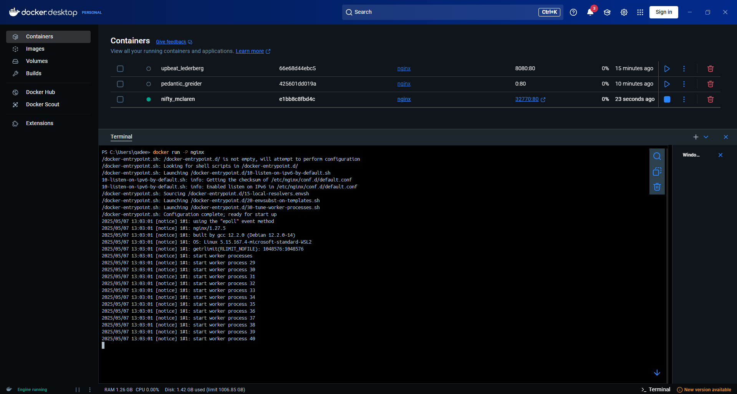

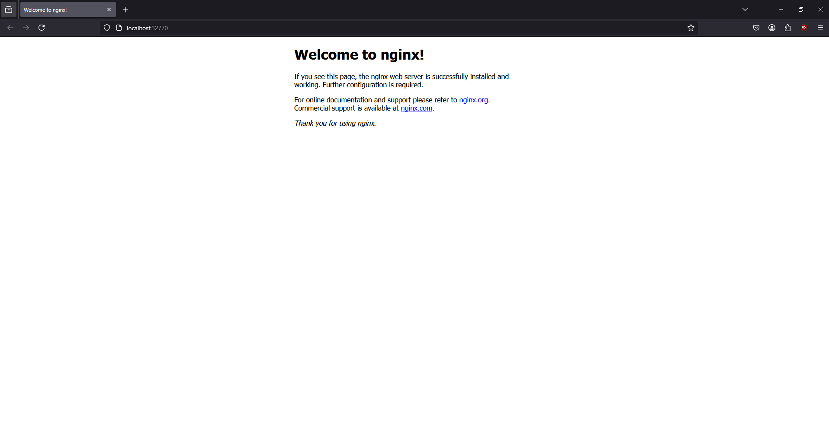

### **Try it out**

#### Use the docker CLI

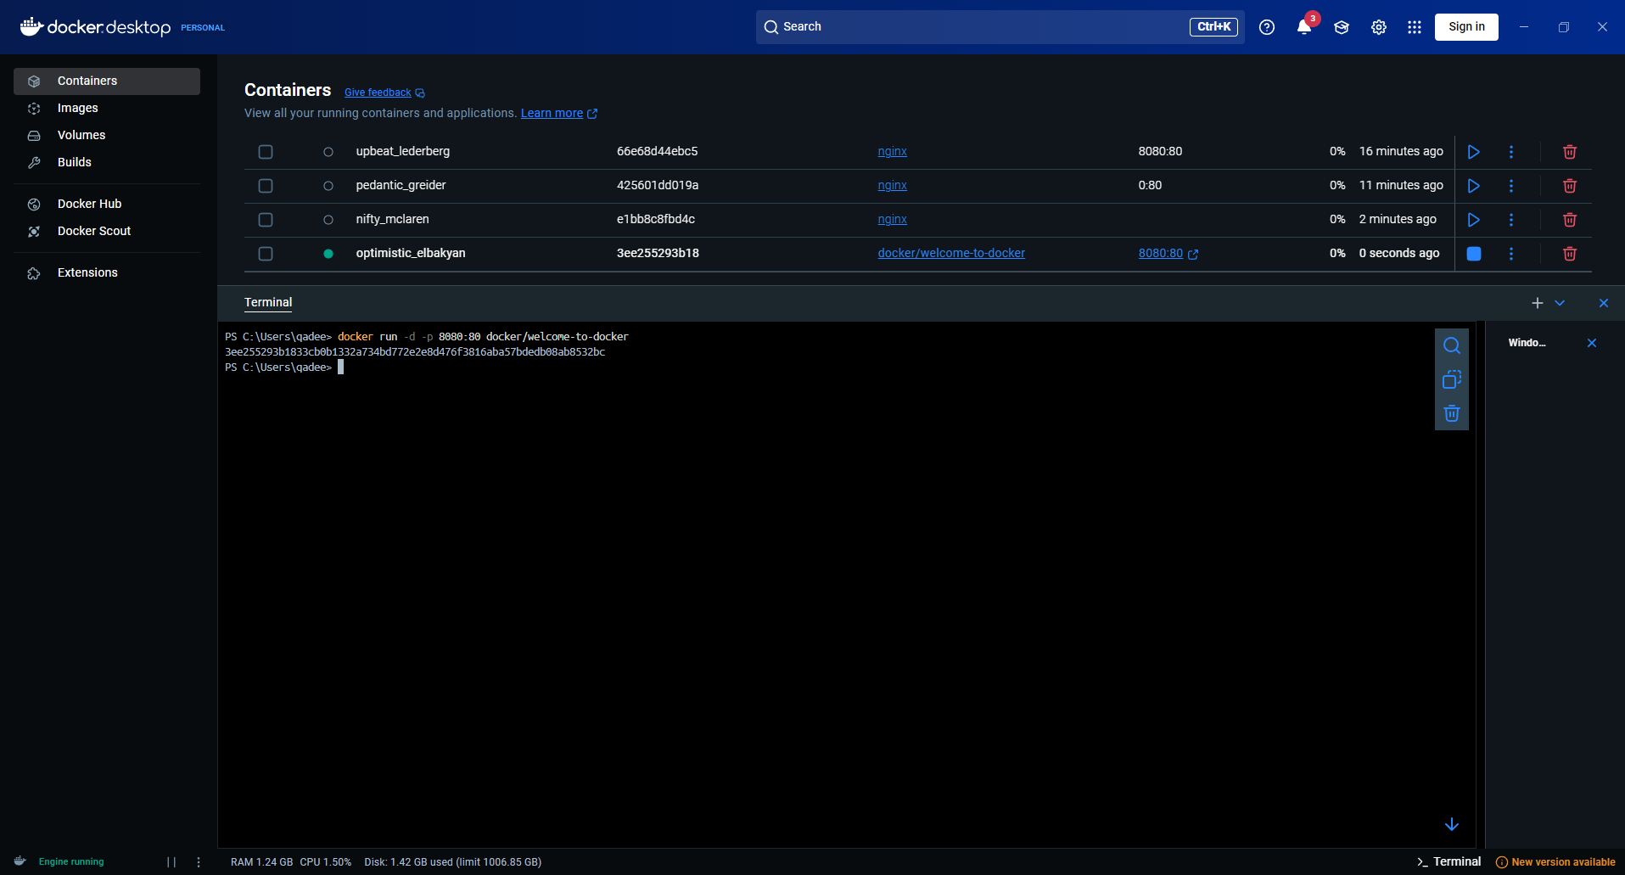

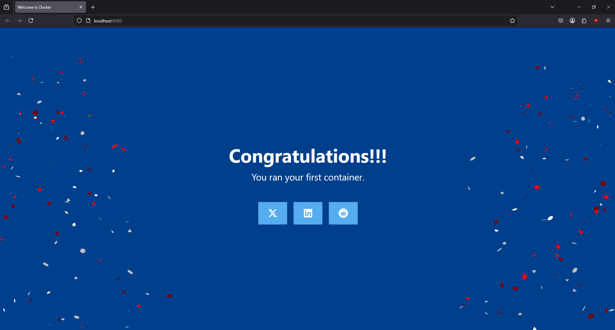

#### Use docker compose

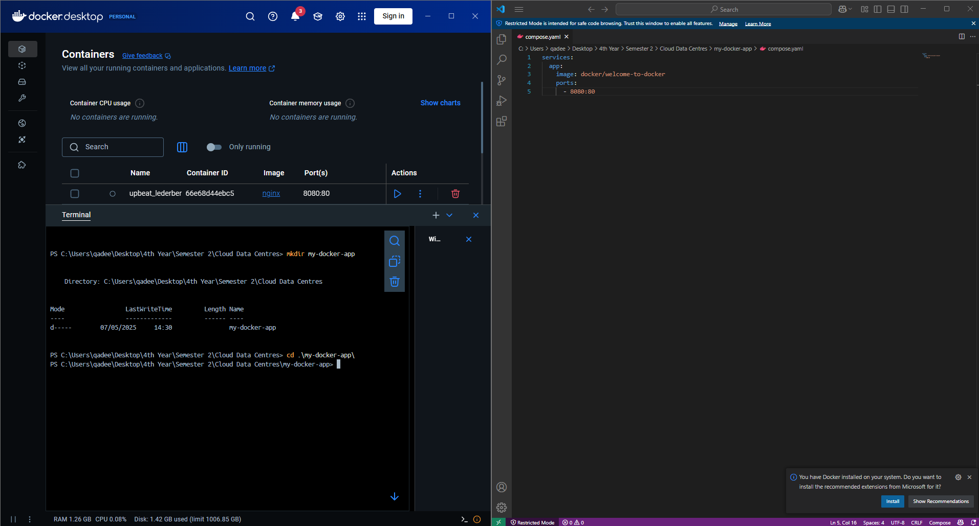

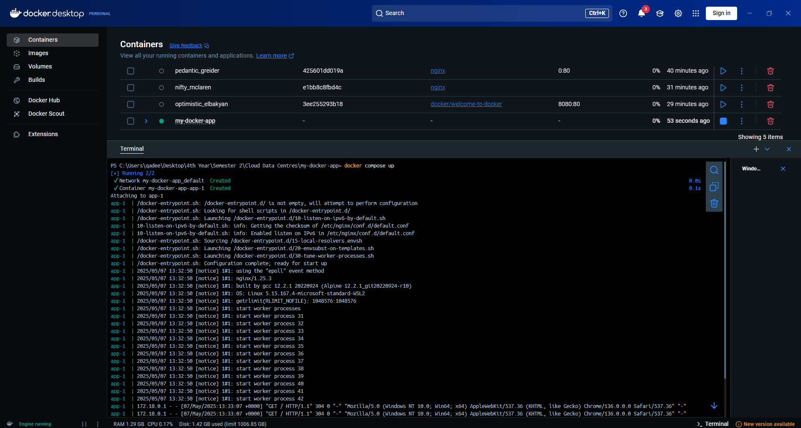

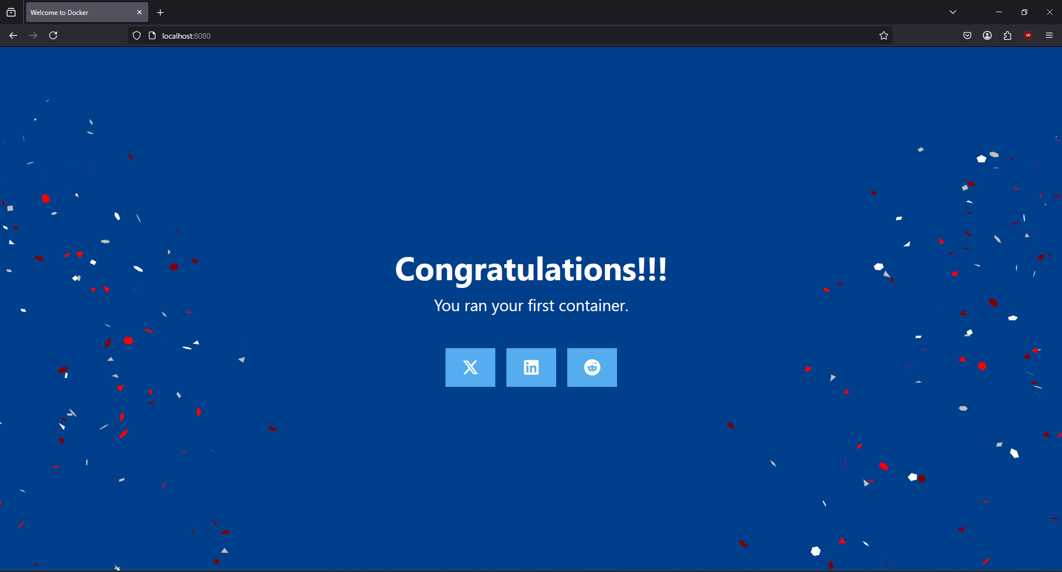

## **Overriding container defaults**

### **Overriding the network ports**

### **Setting environmental variables**

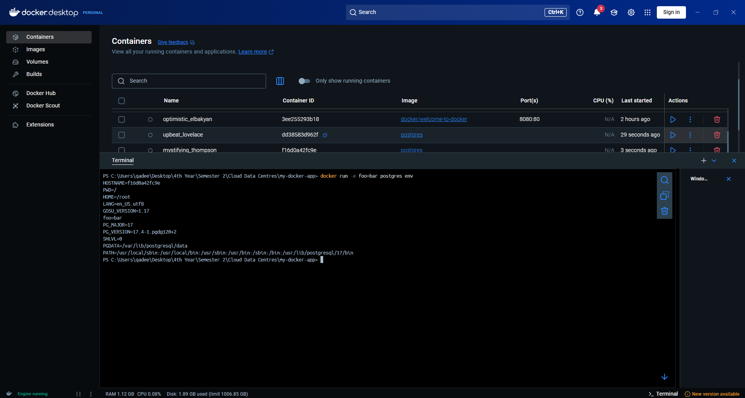

### **Restrciting the container to consume the resources**

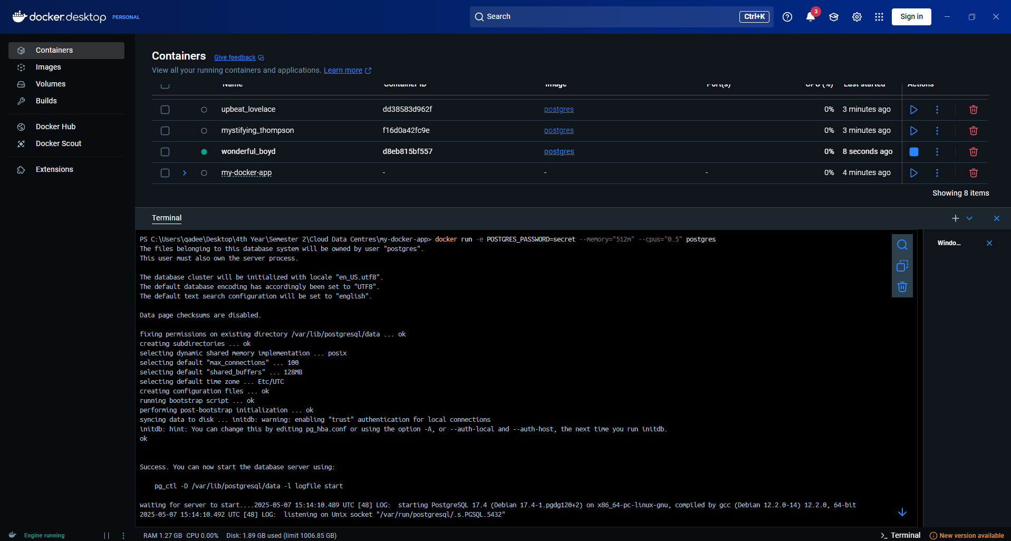

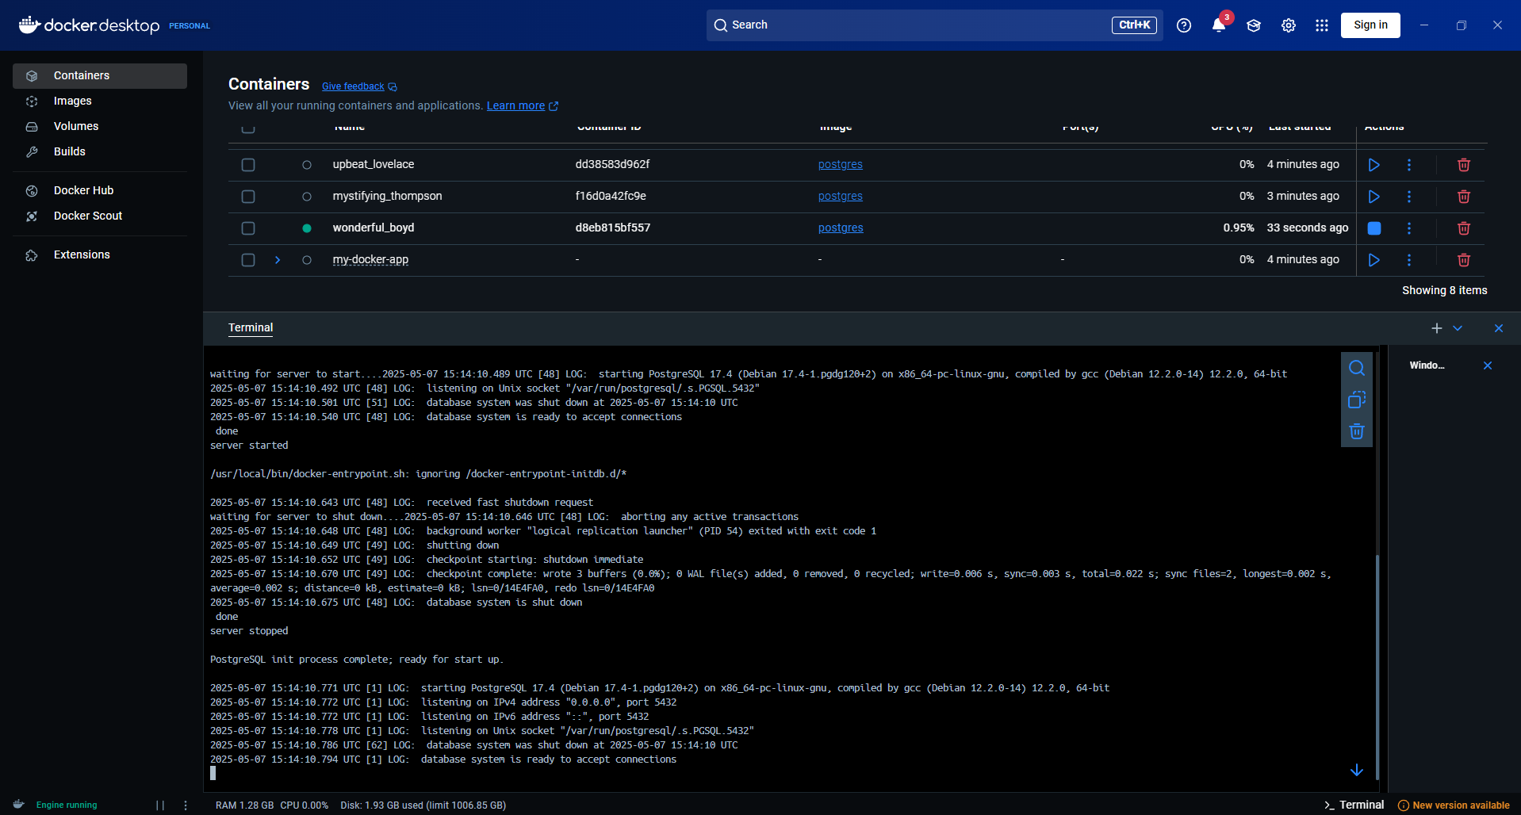

### **Try it out**

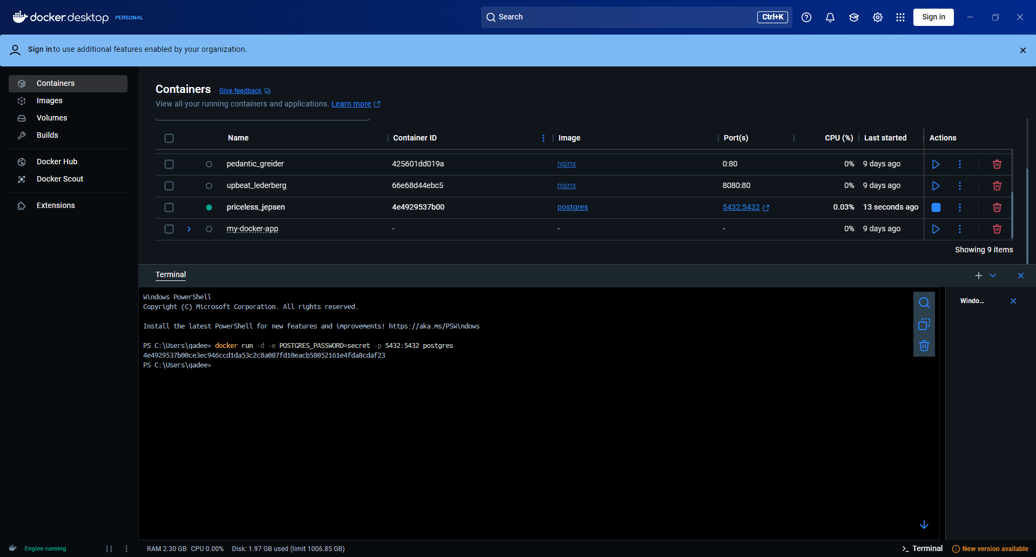

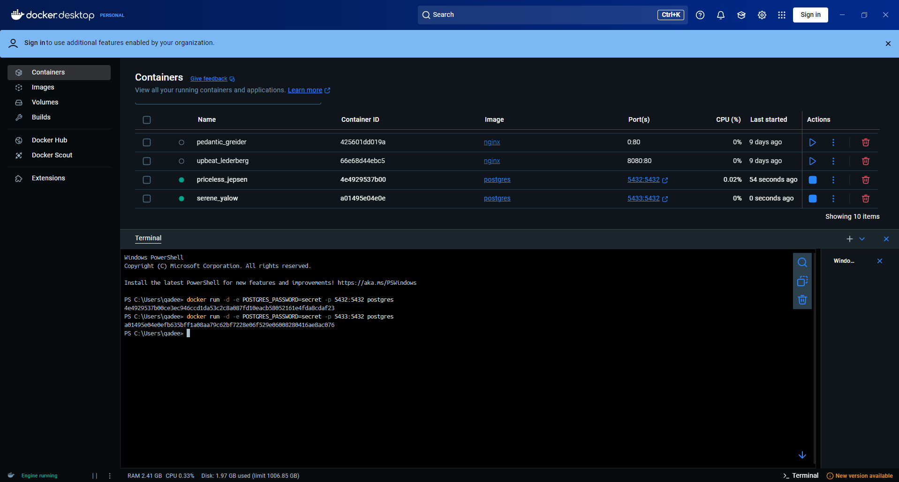

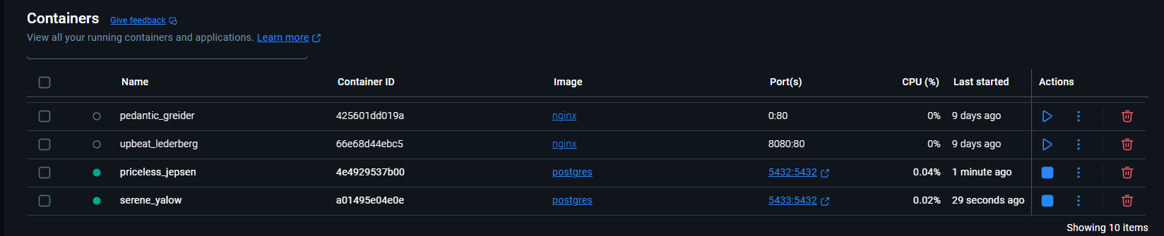

#### **Run Postgres container in a controlled network**

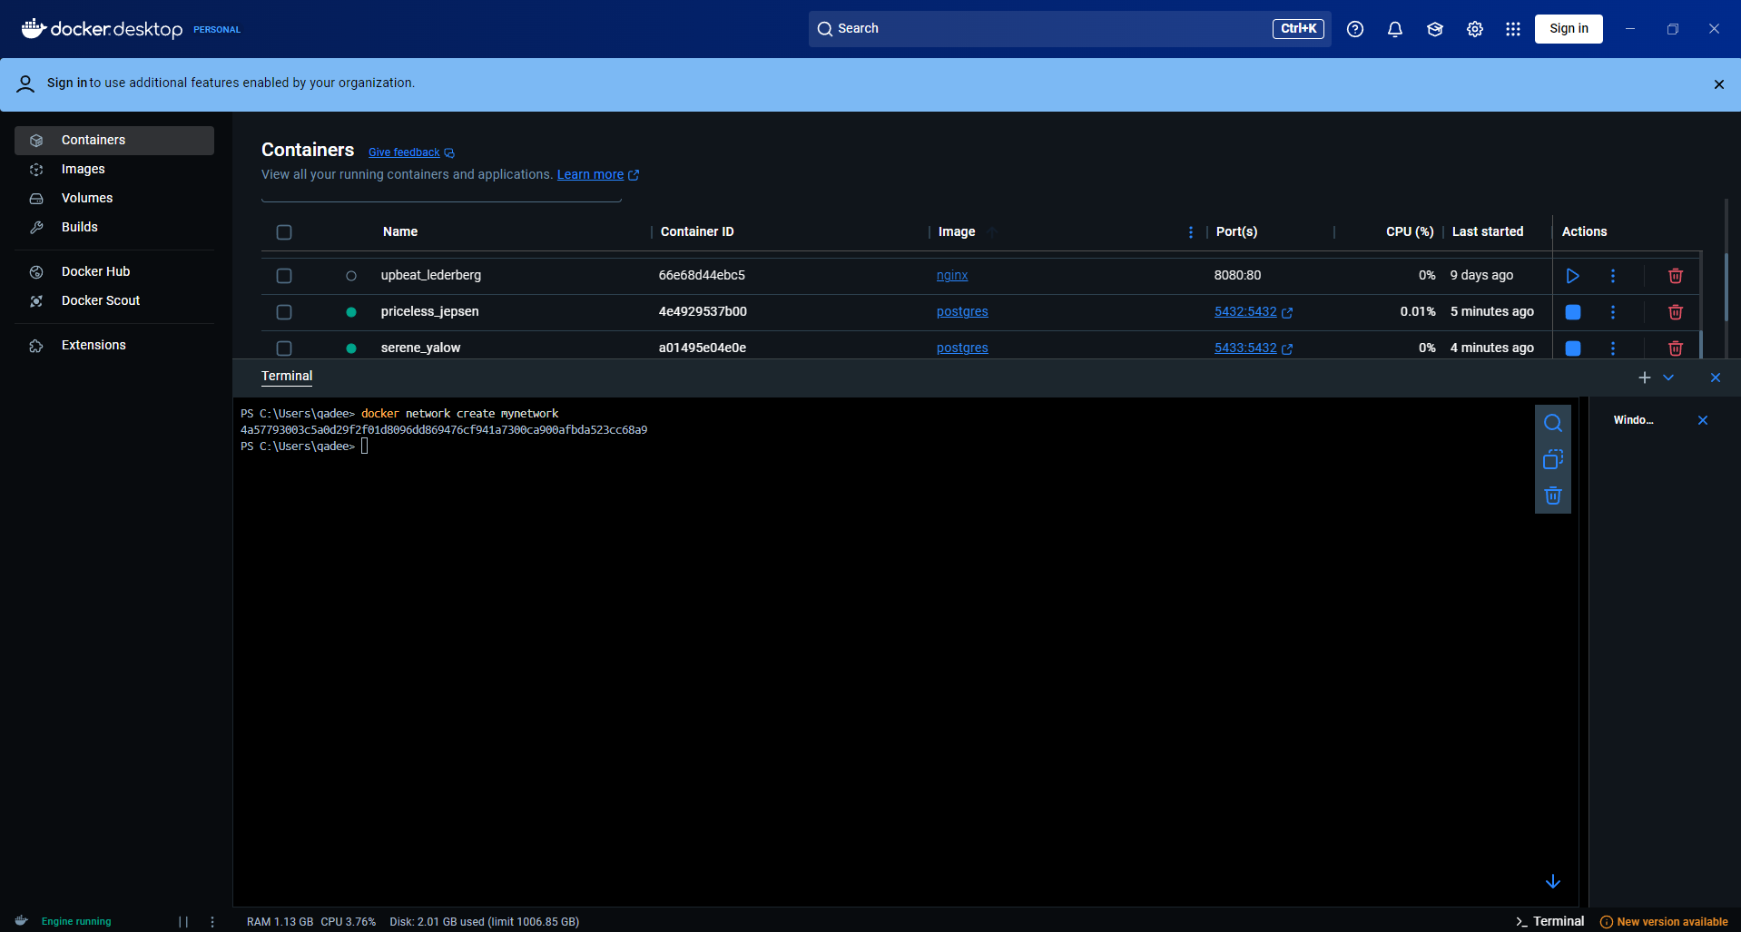

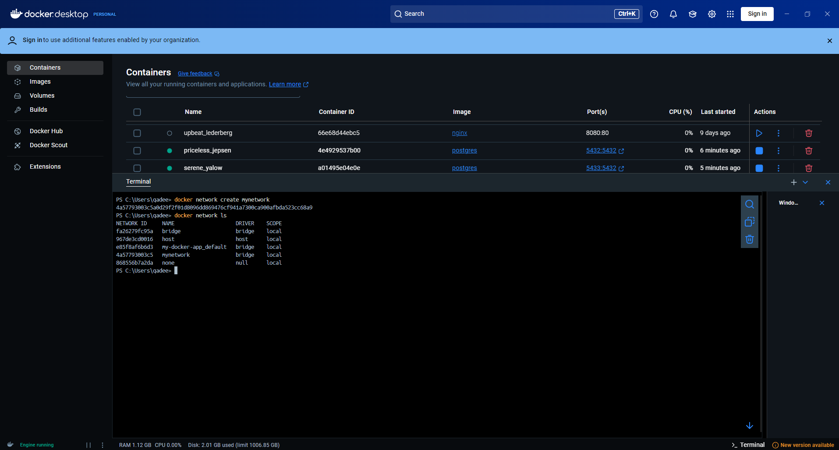

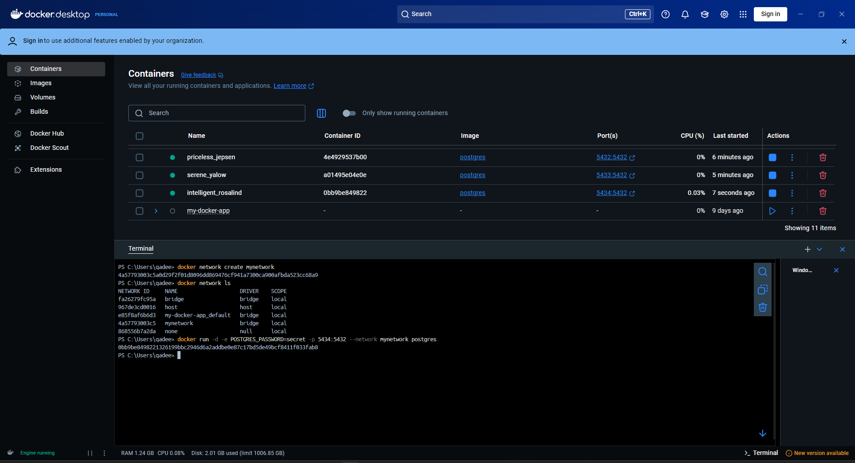



#### **Manage the resources**

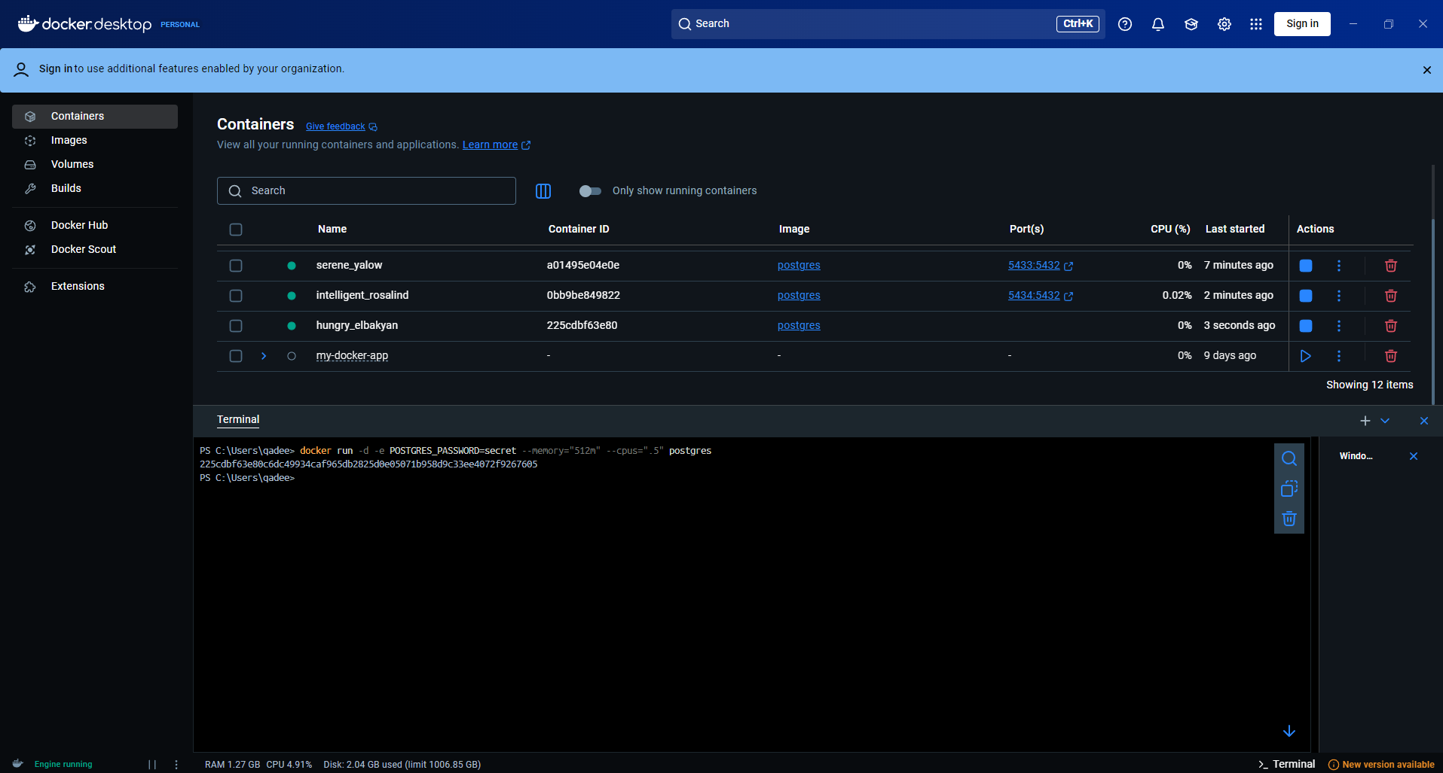



#### **Override the default CMD and ENTRYPOINT in Docker Compose**

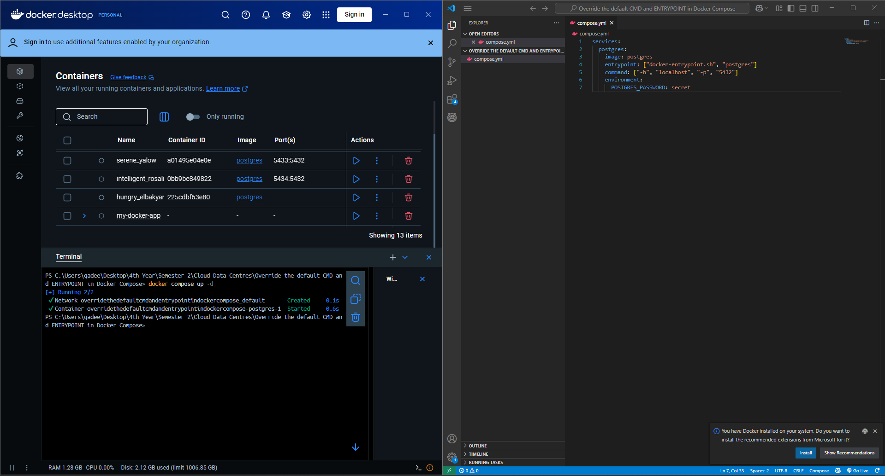

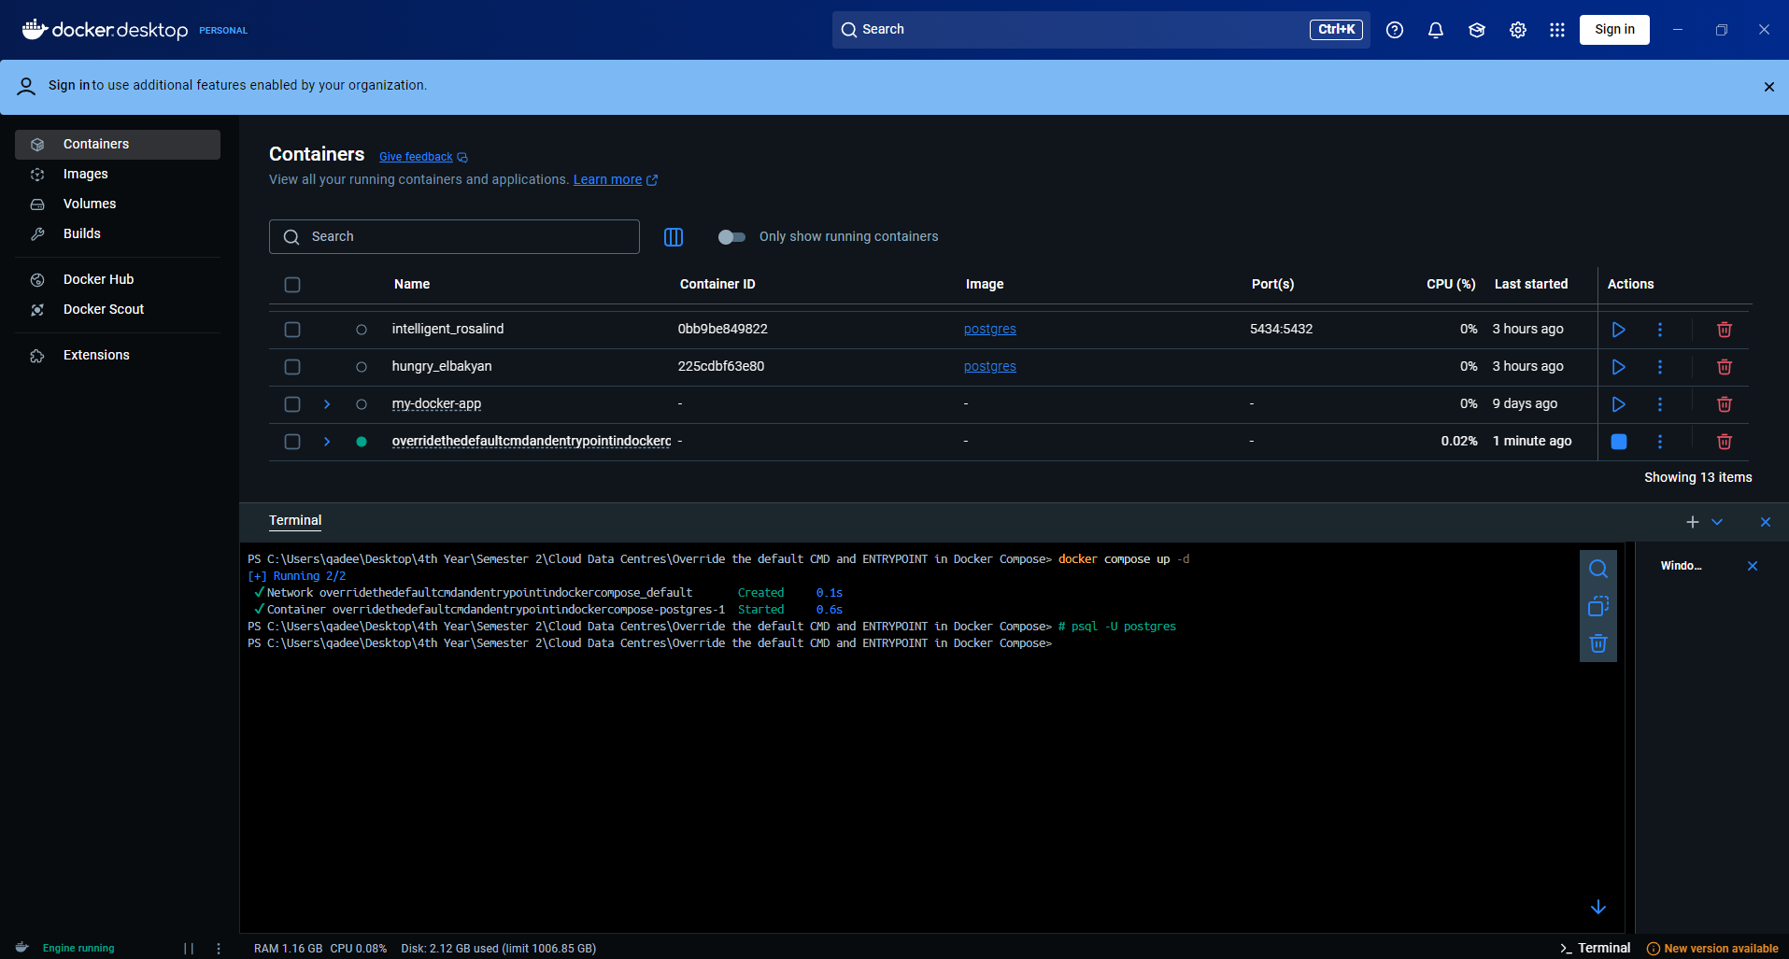

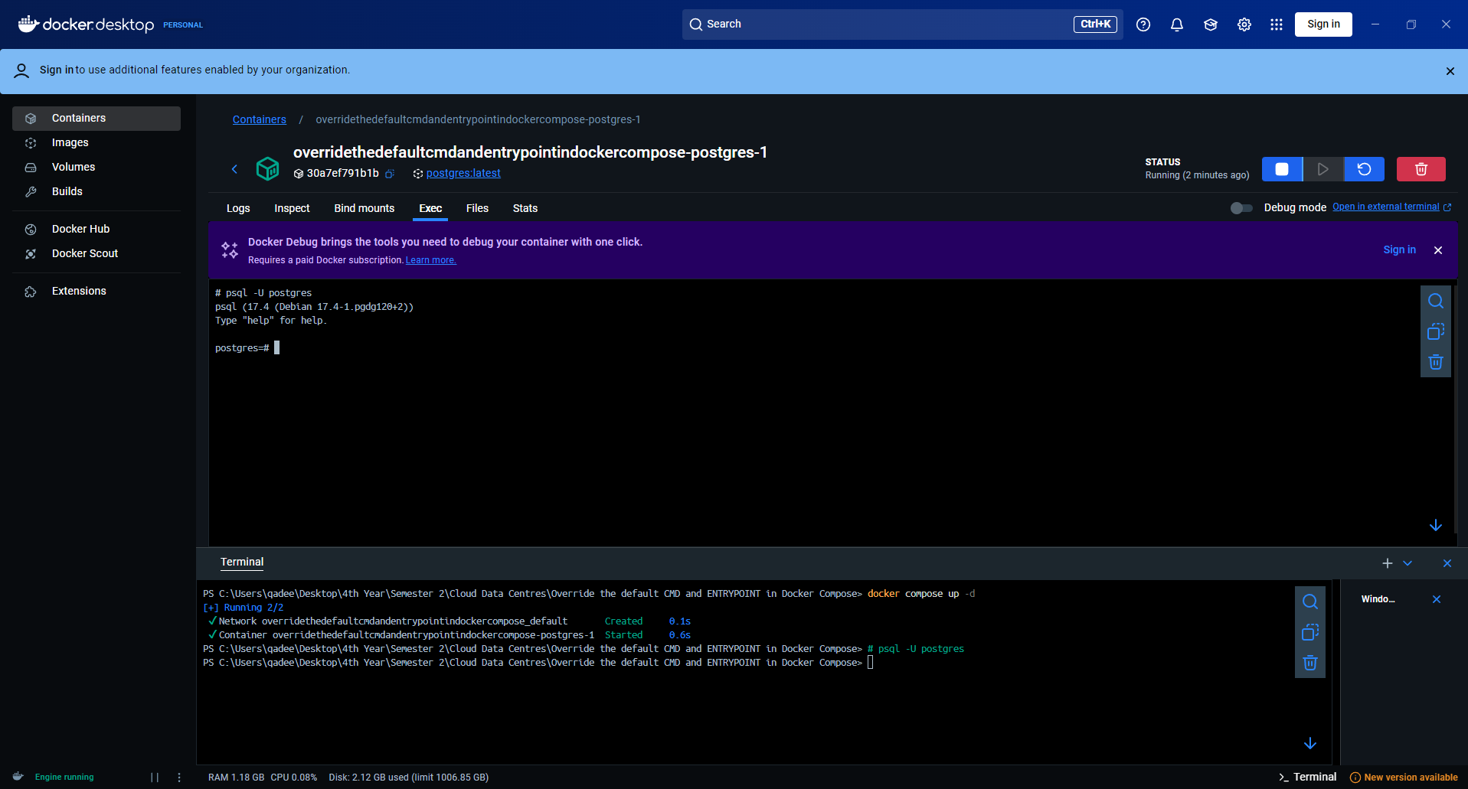

#### **Override the default CMD and ENTRYPOINT with docker run**

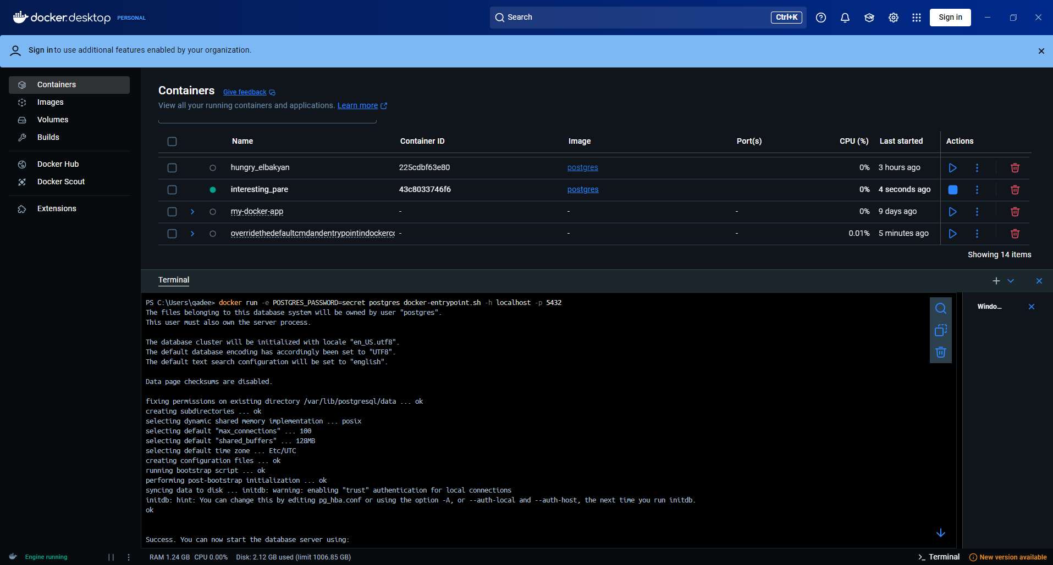

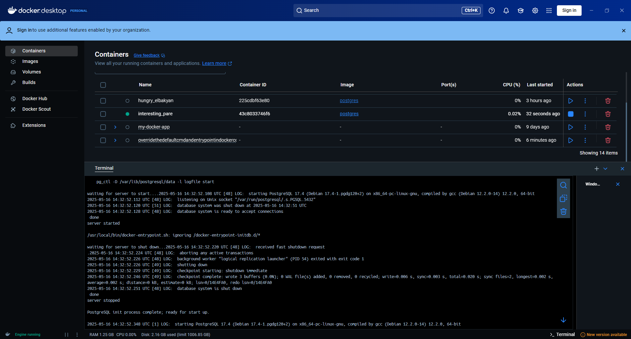

## **Persisting container data**

### **Container volumes**

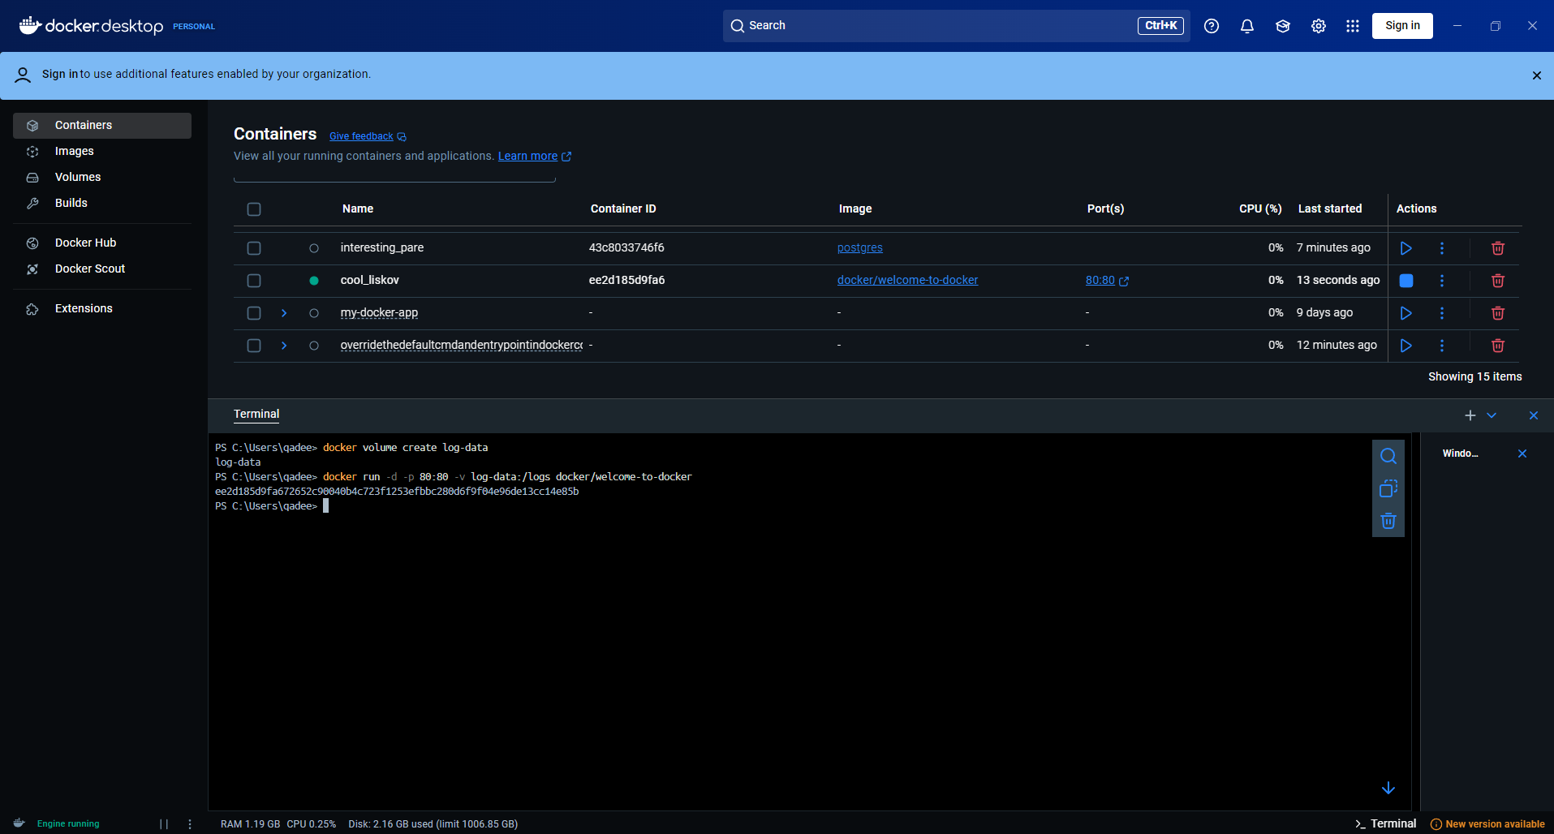

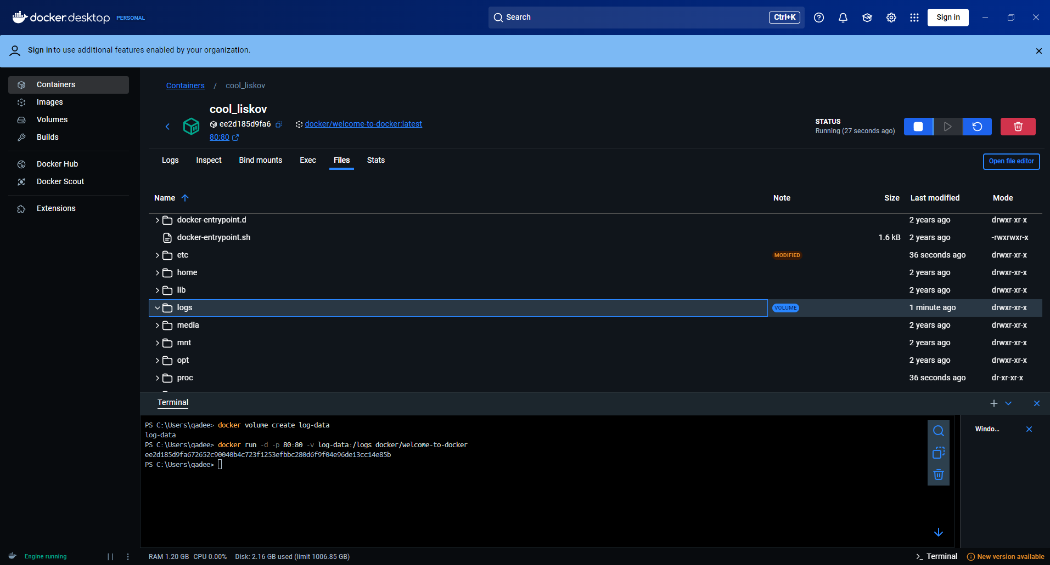

### **Managing volumes**

### **Try it out**

#### **Use volumes**

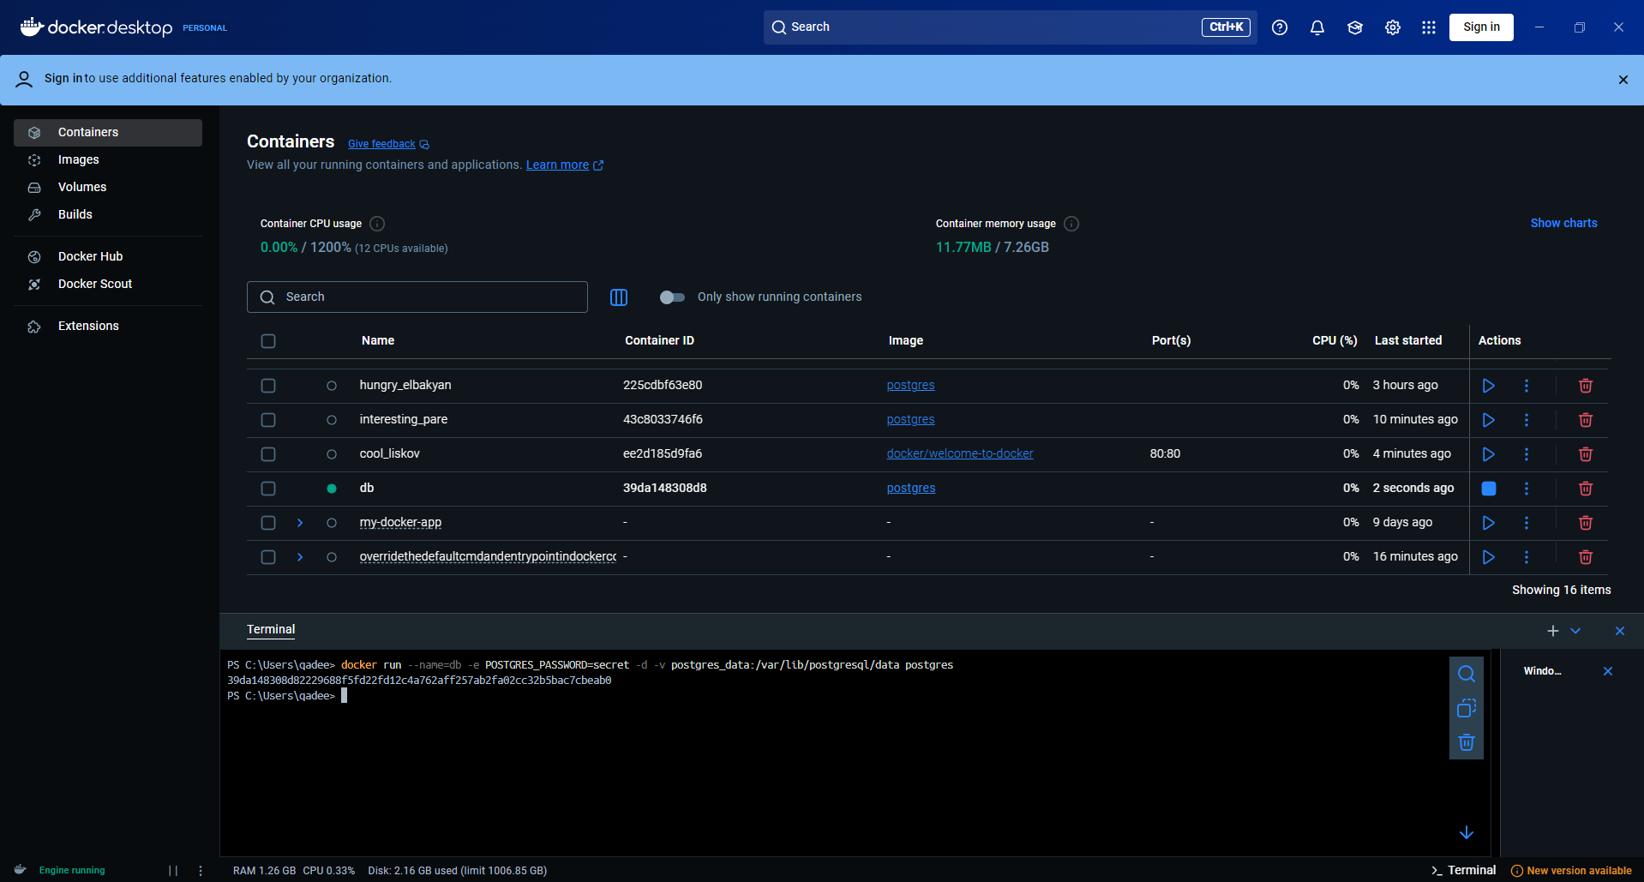

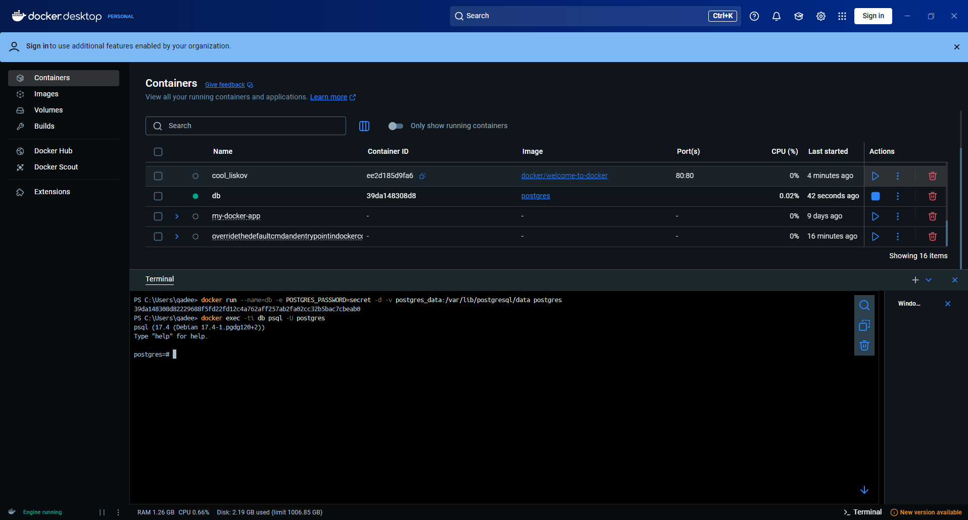

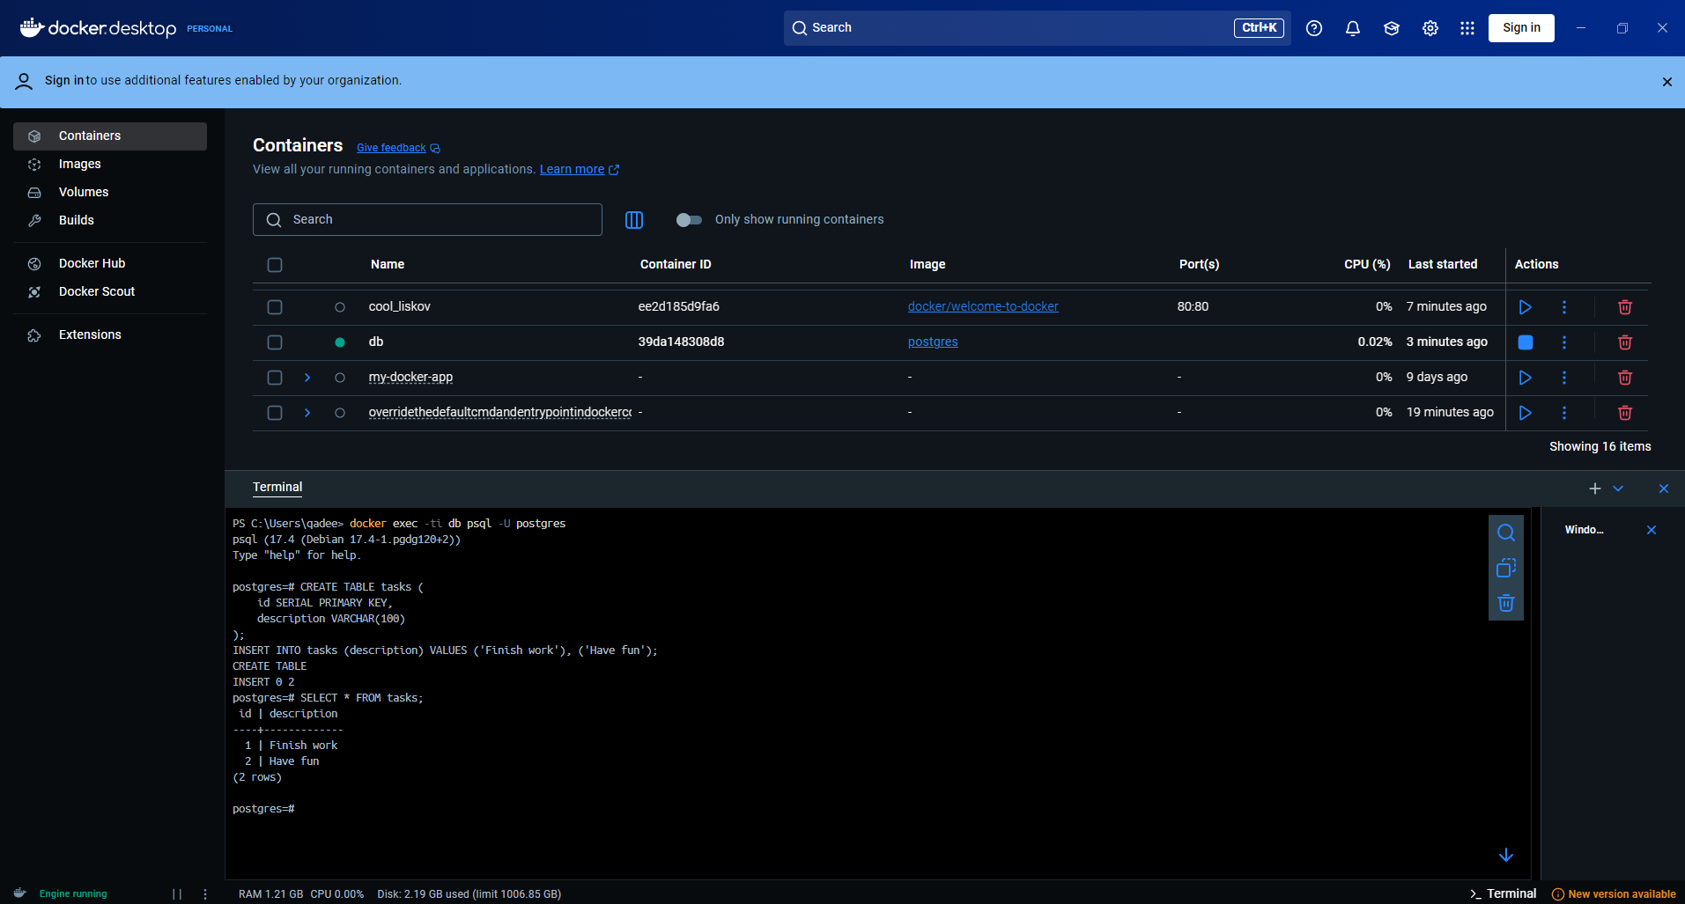

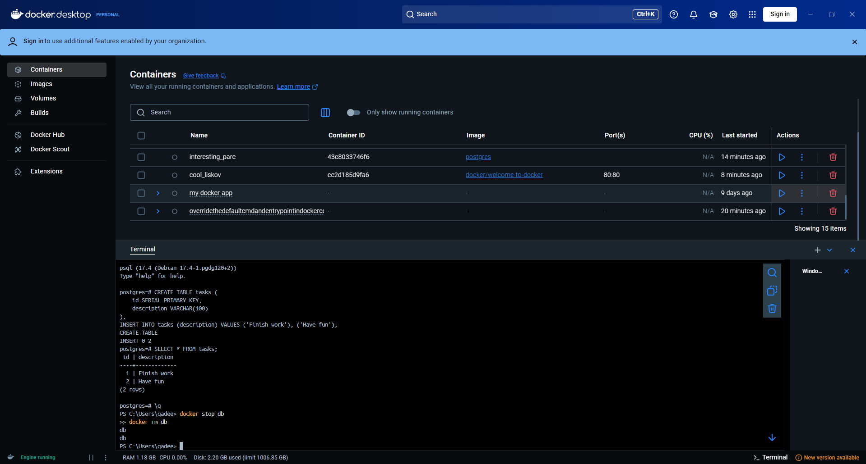

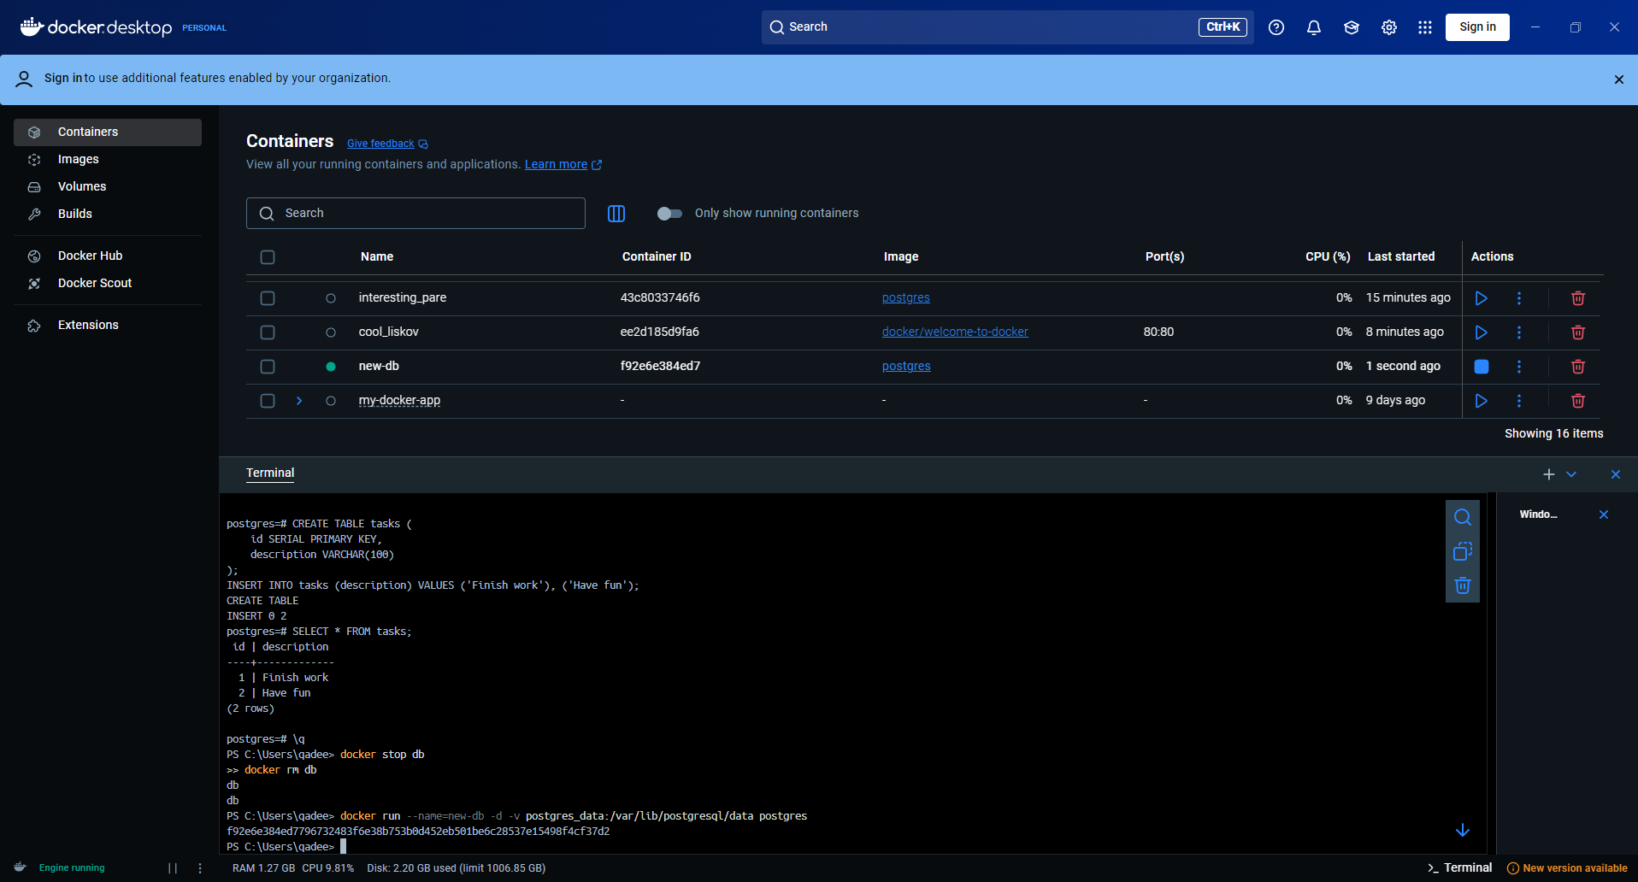

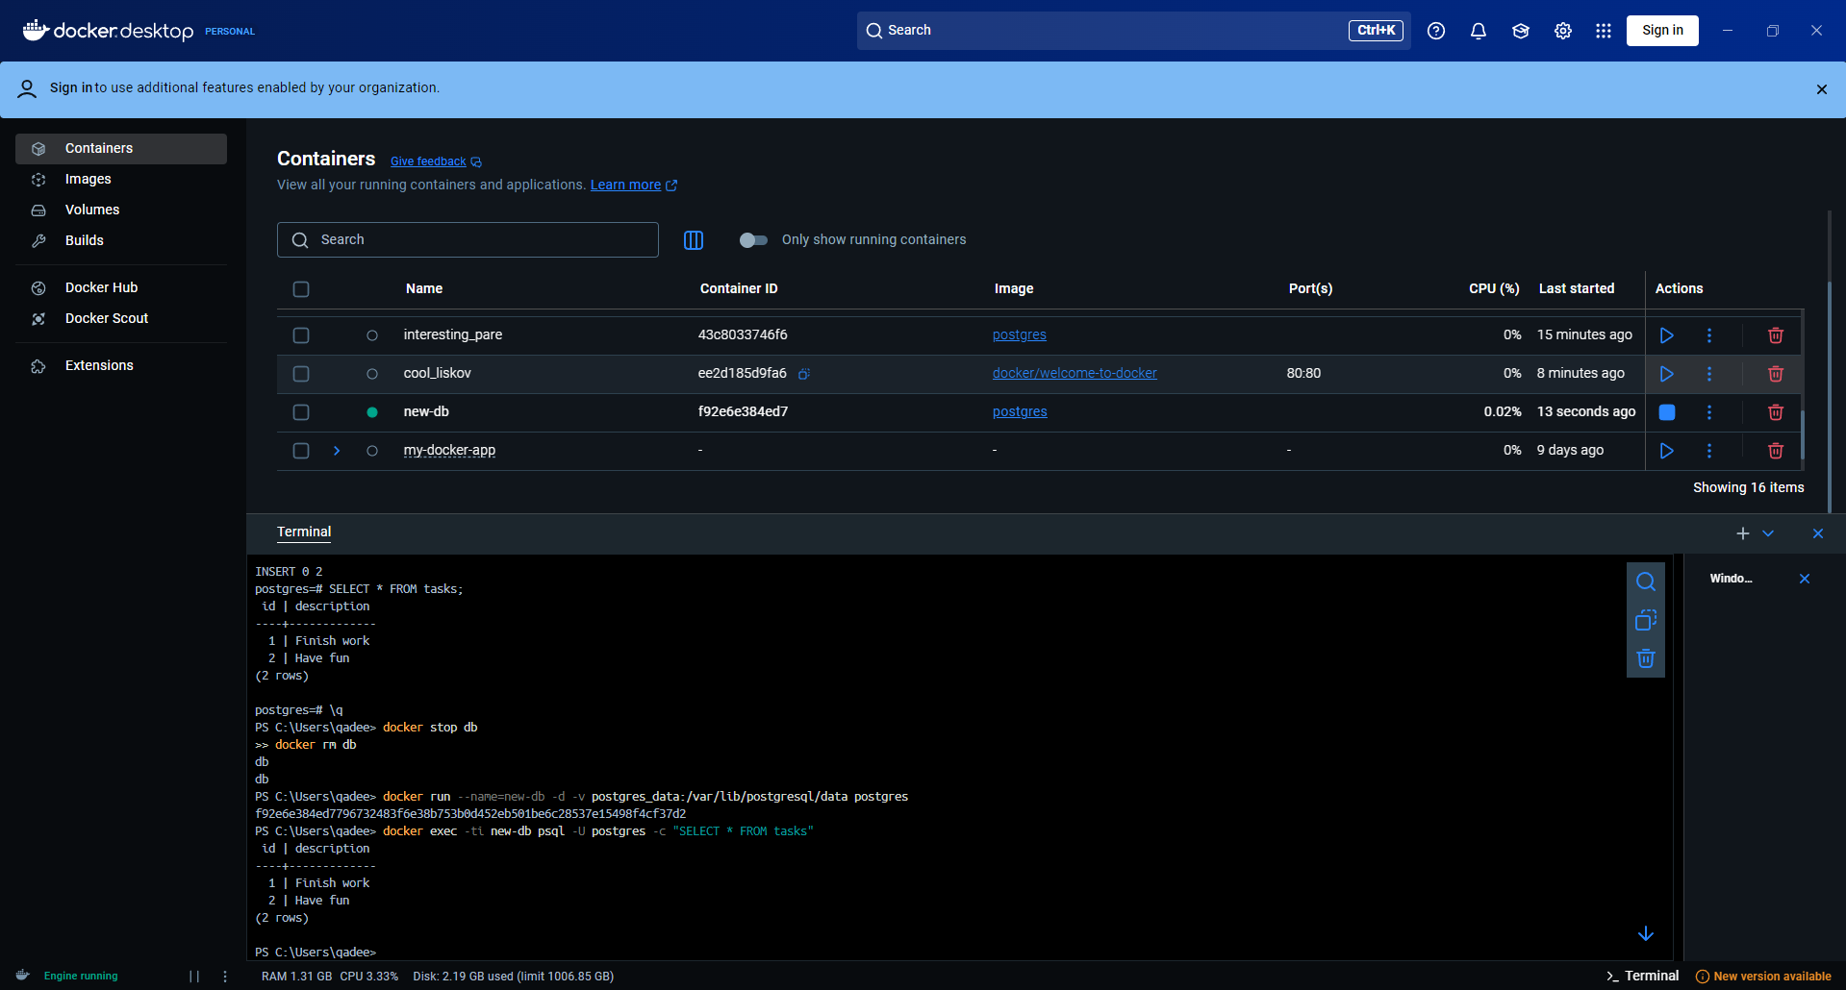

#### **View volume contents**

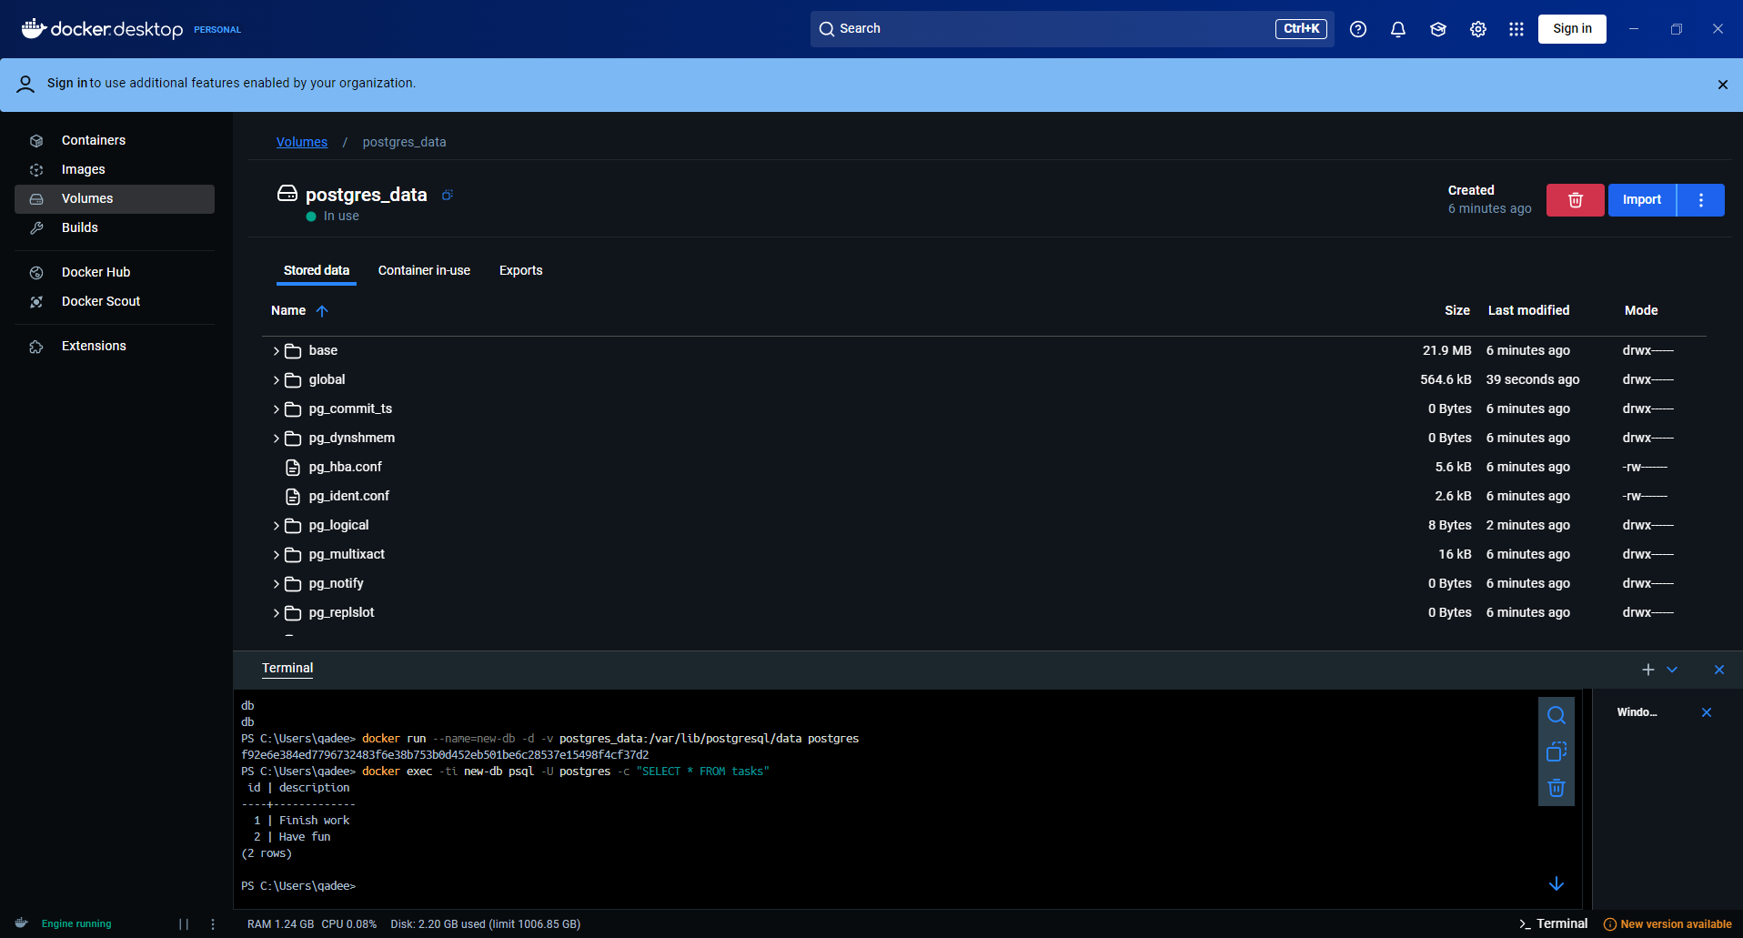

#### **Remove volumes**

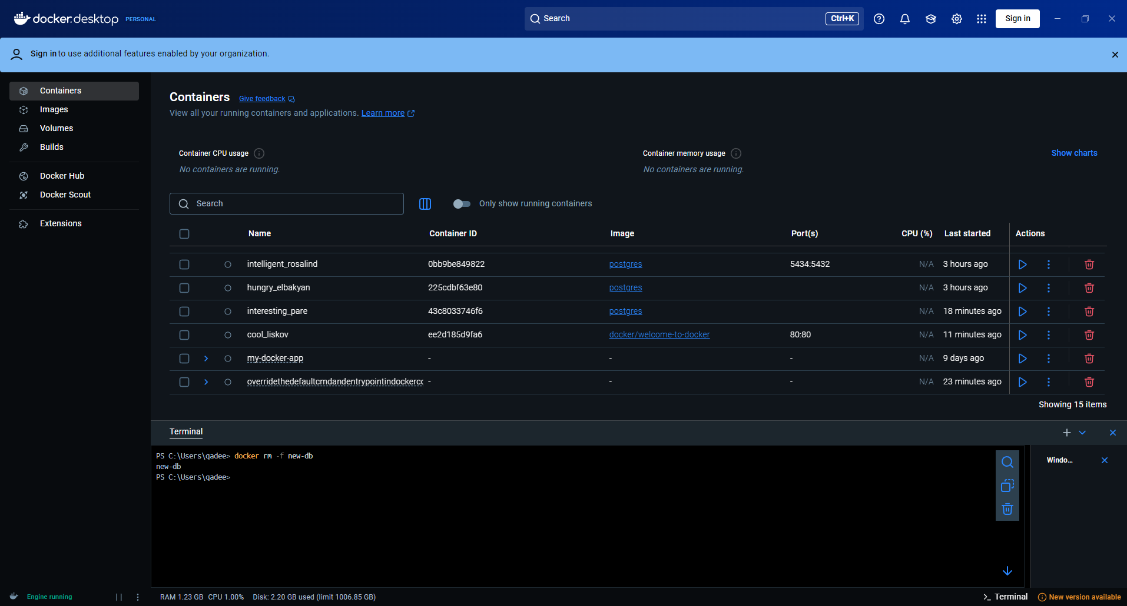

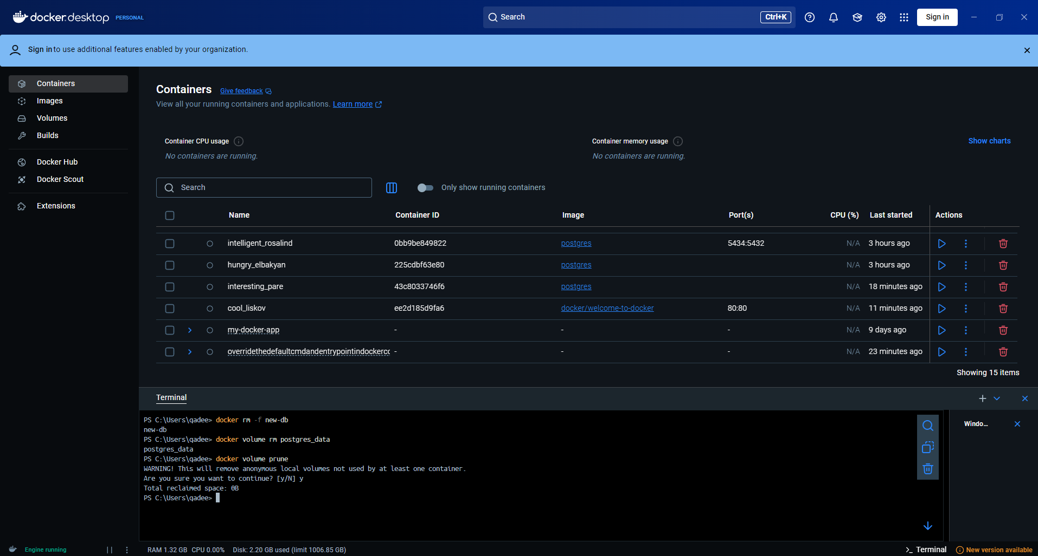

## **Sharing local files with containers**

### **Volume versus bind mounts**

### **Sharing files between a host and container**

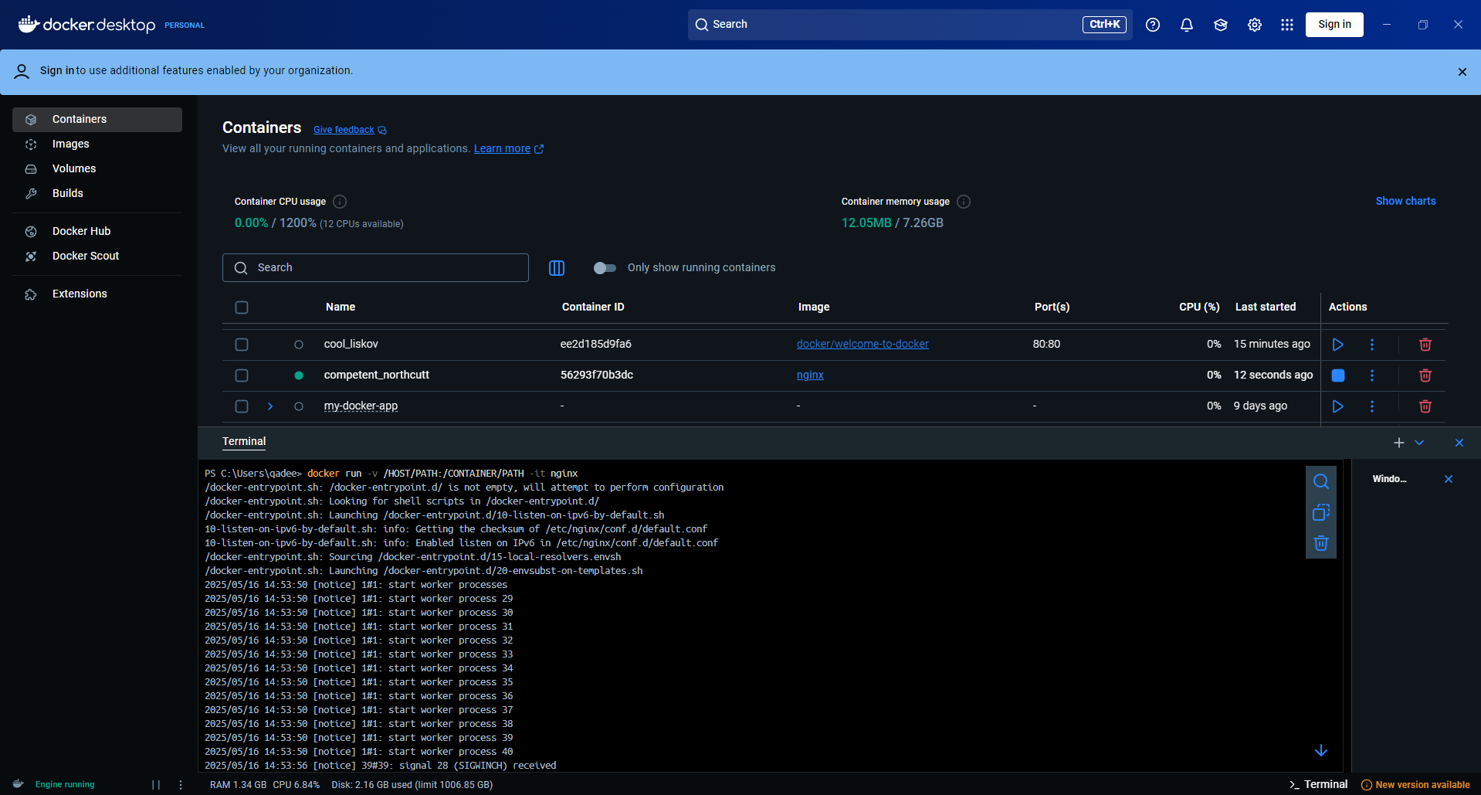

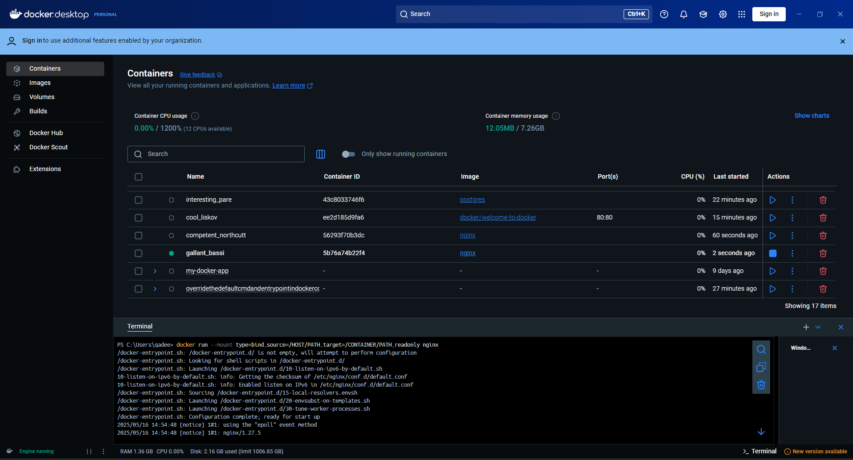

### **File permissions for Docker access to host files**

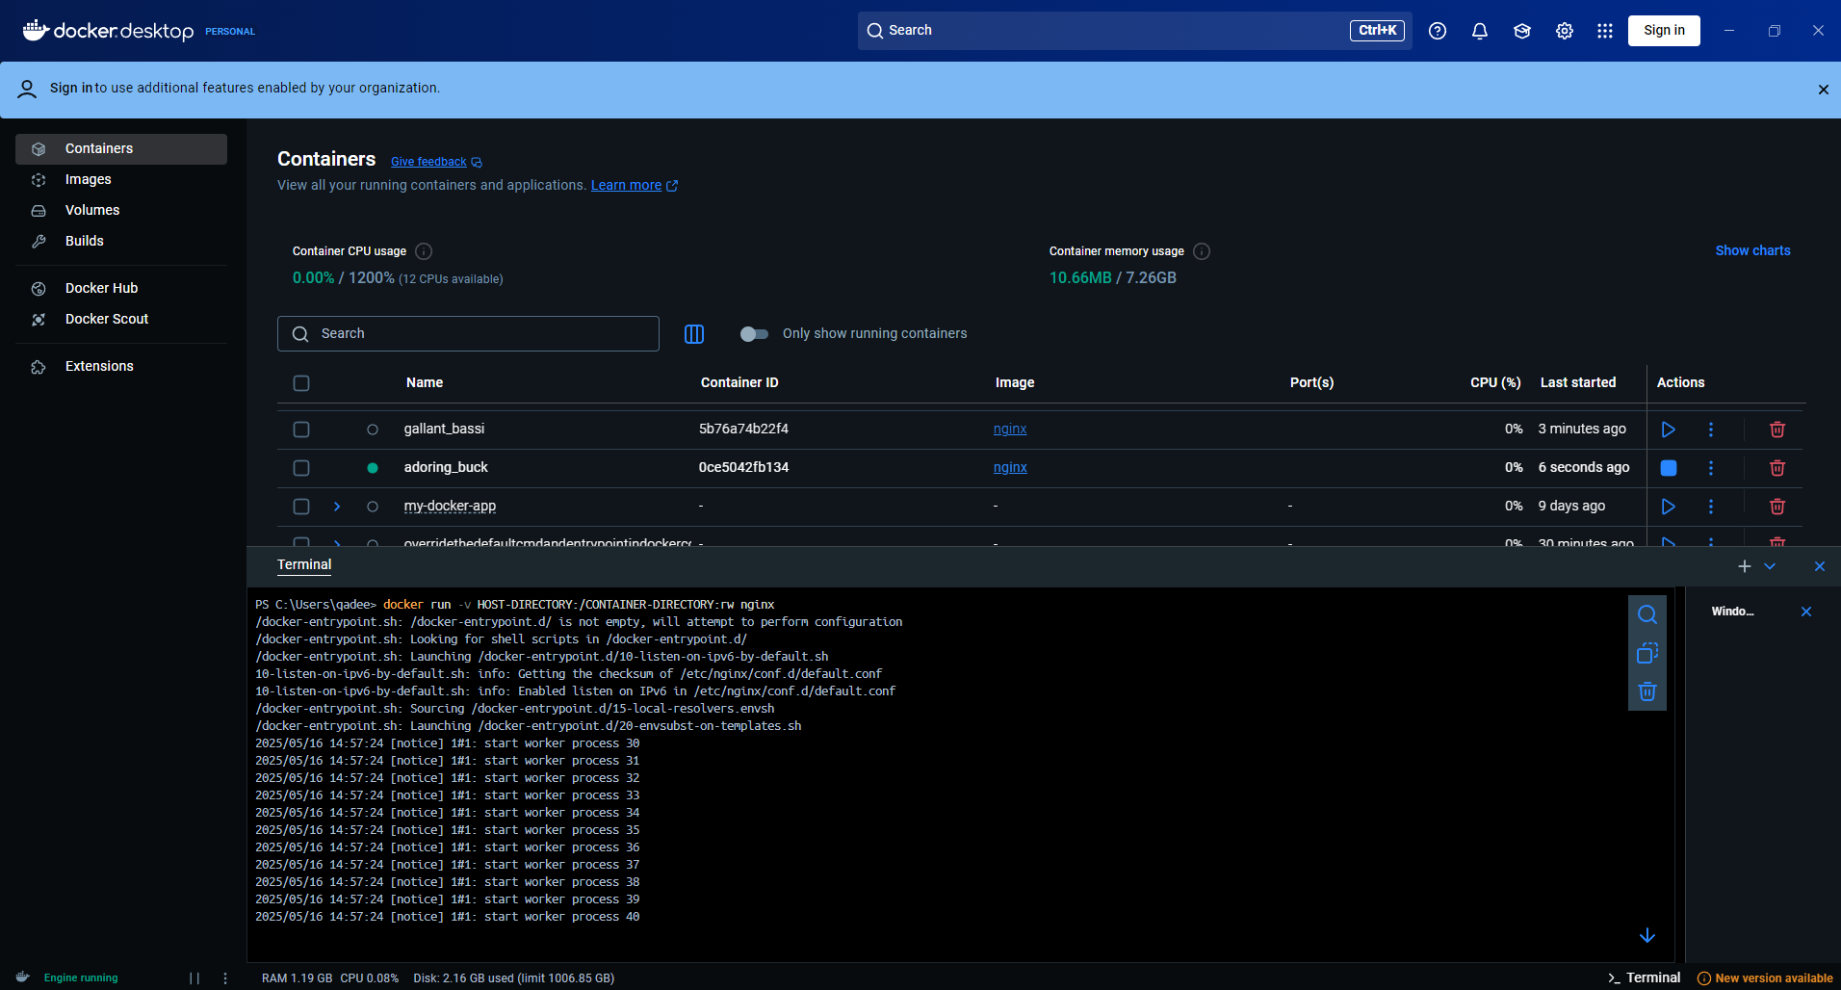

### **Try it out**

#### **Run a container**

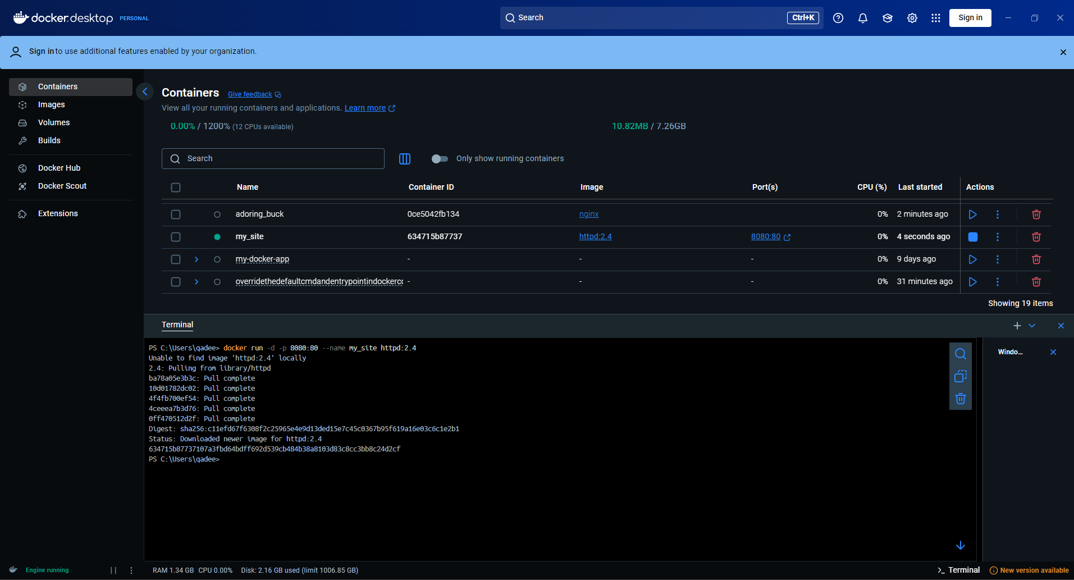

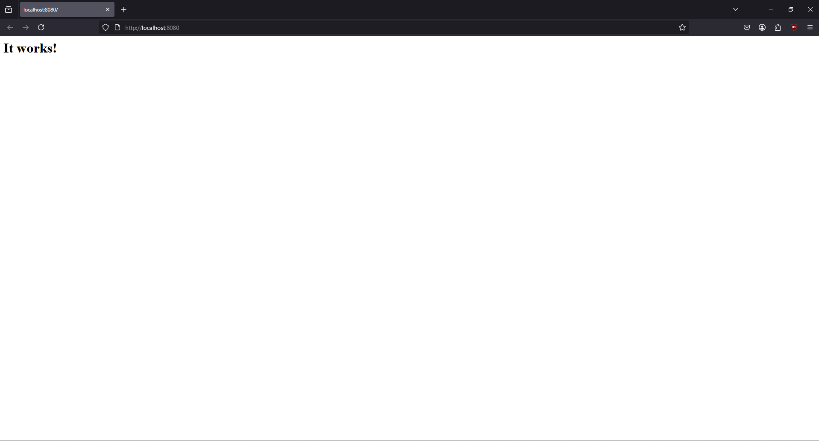

#### **Use a bind mount**

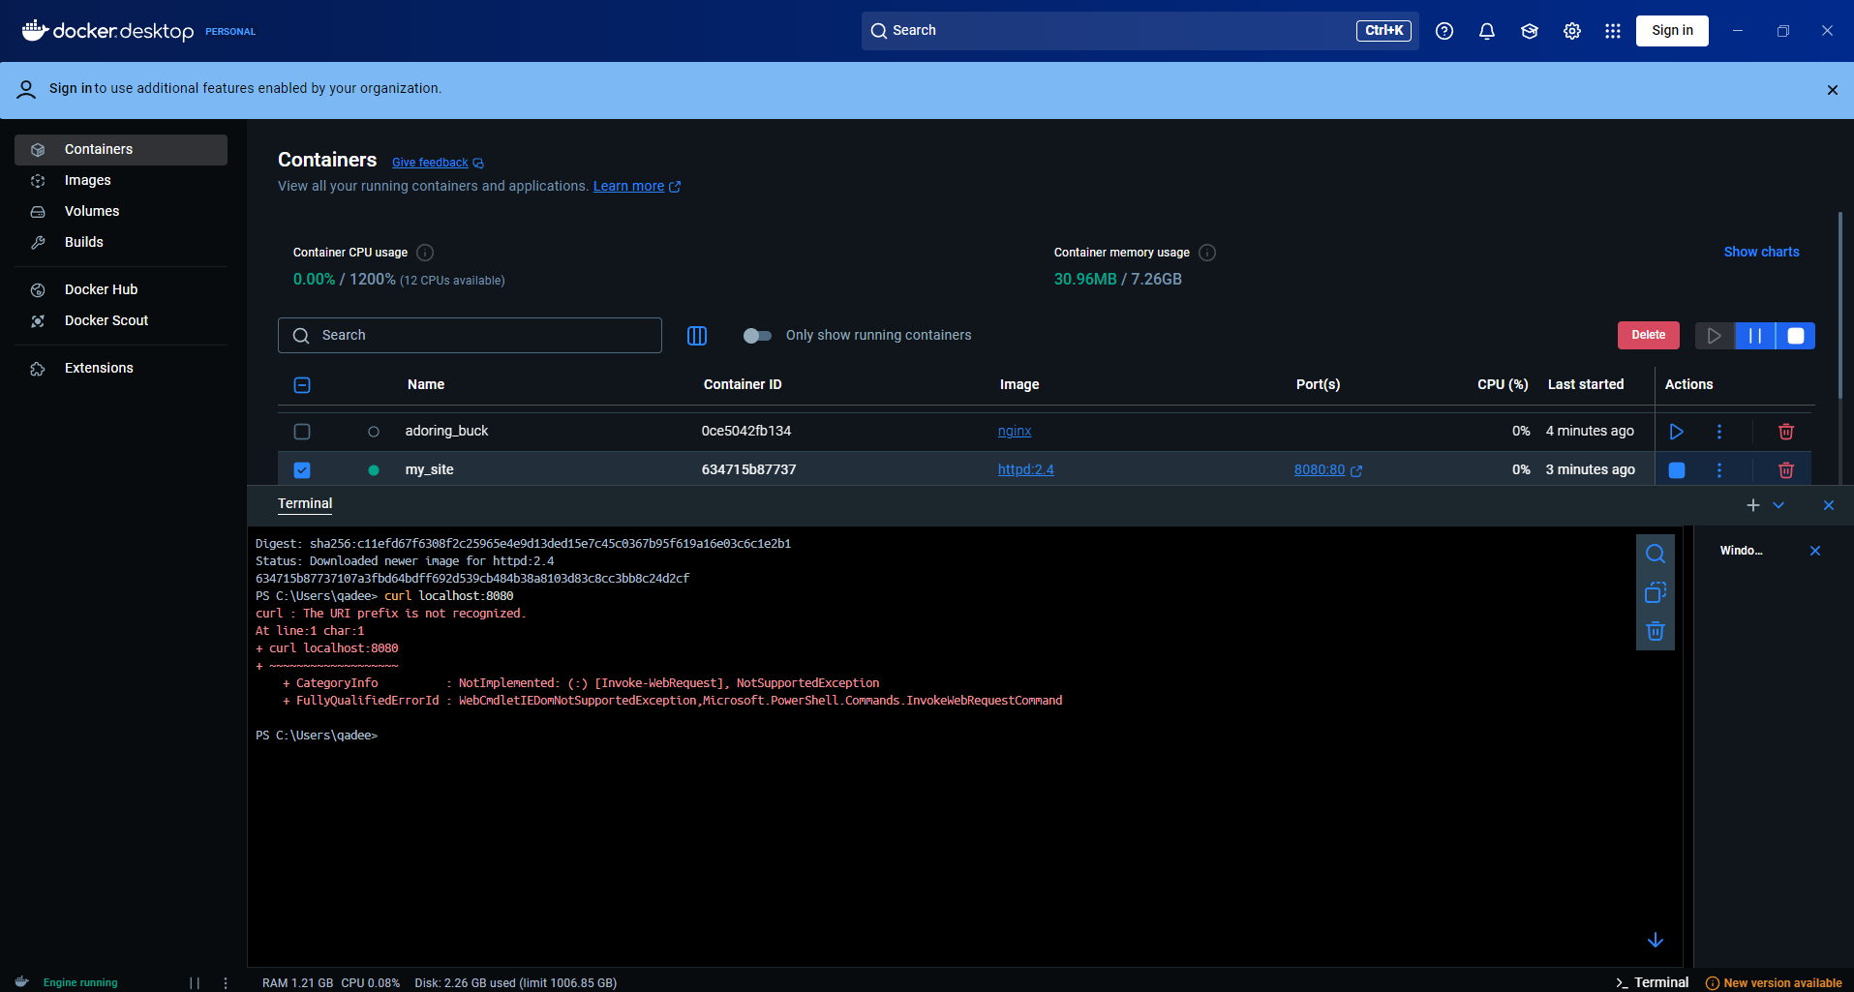

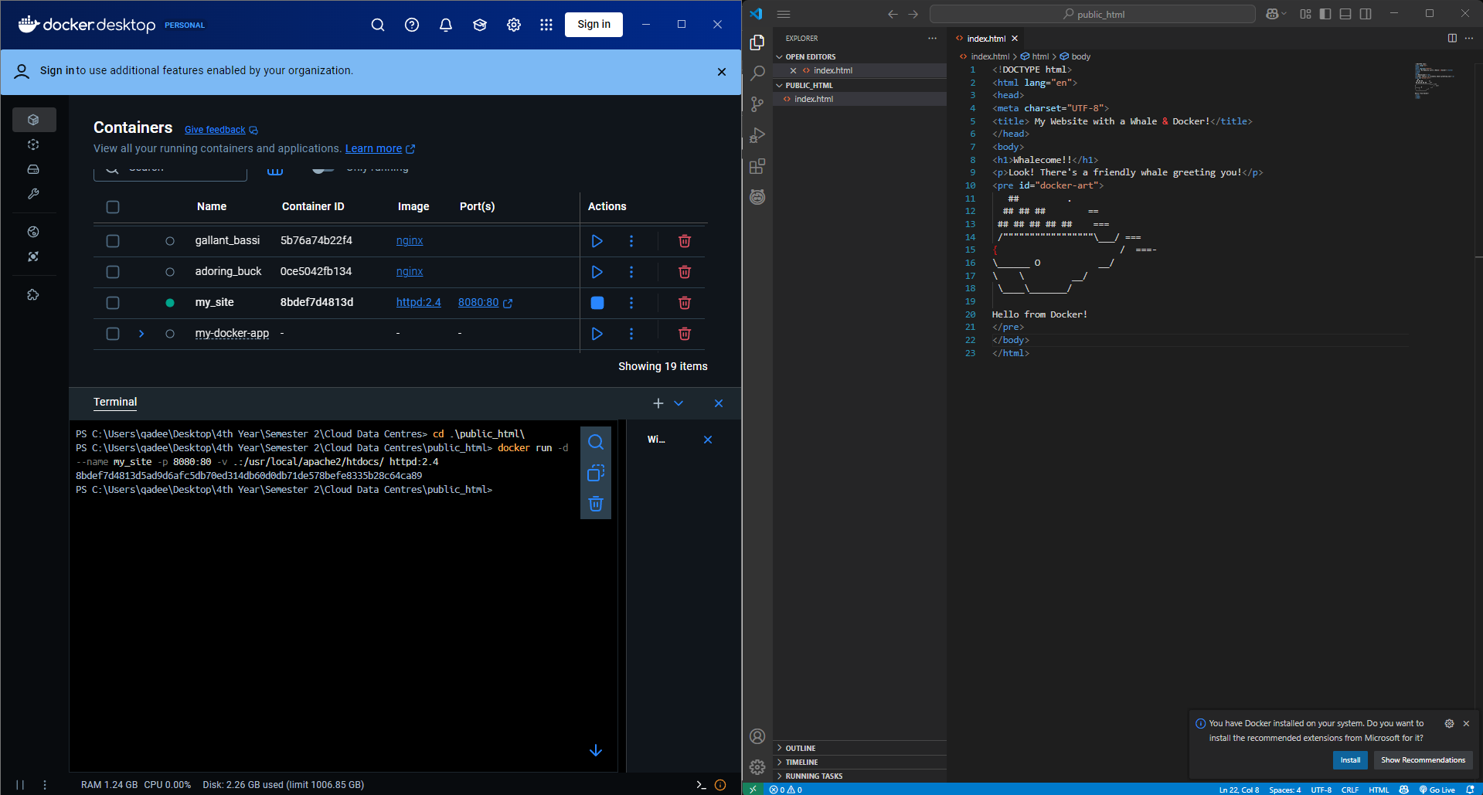

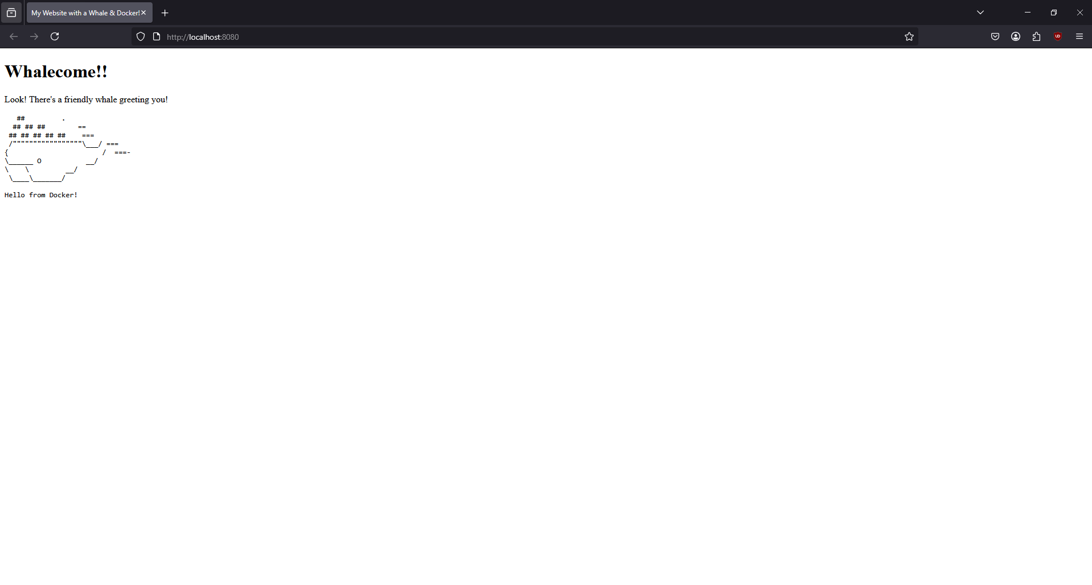

#### **Access the file on the Docker Desktop Dashboard**

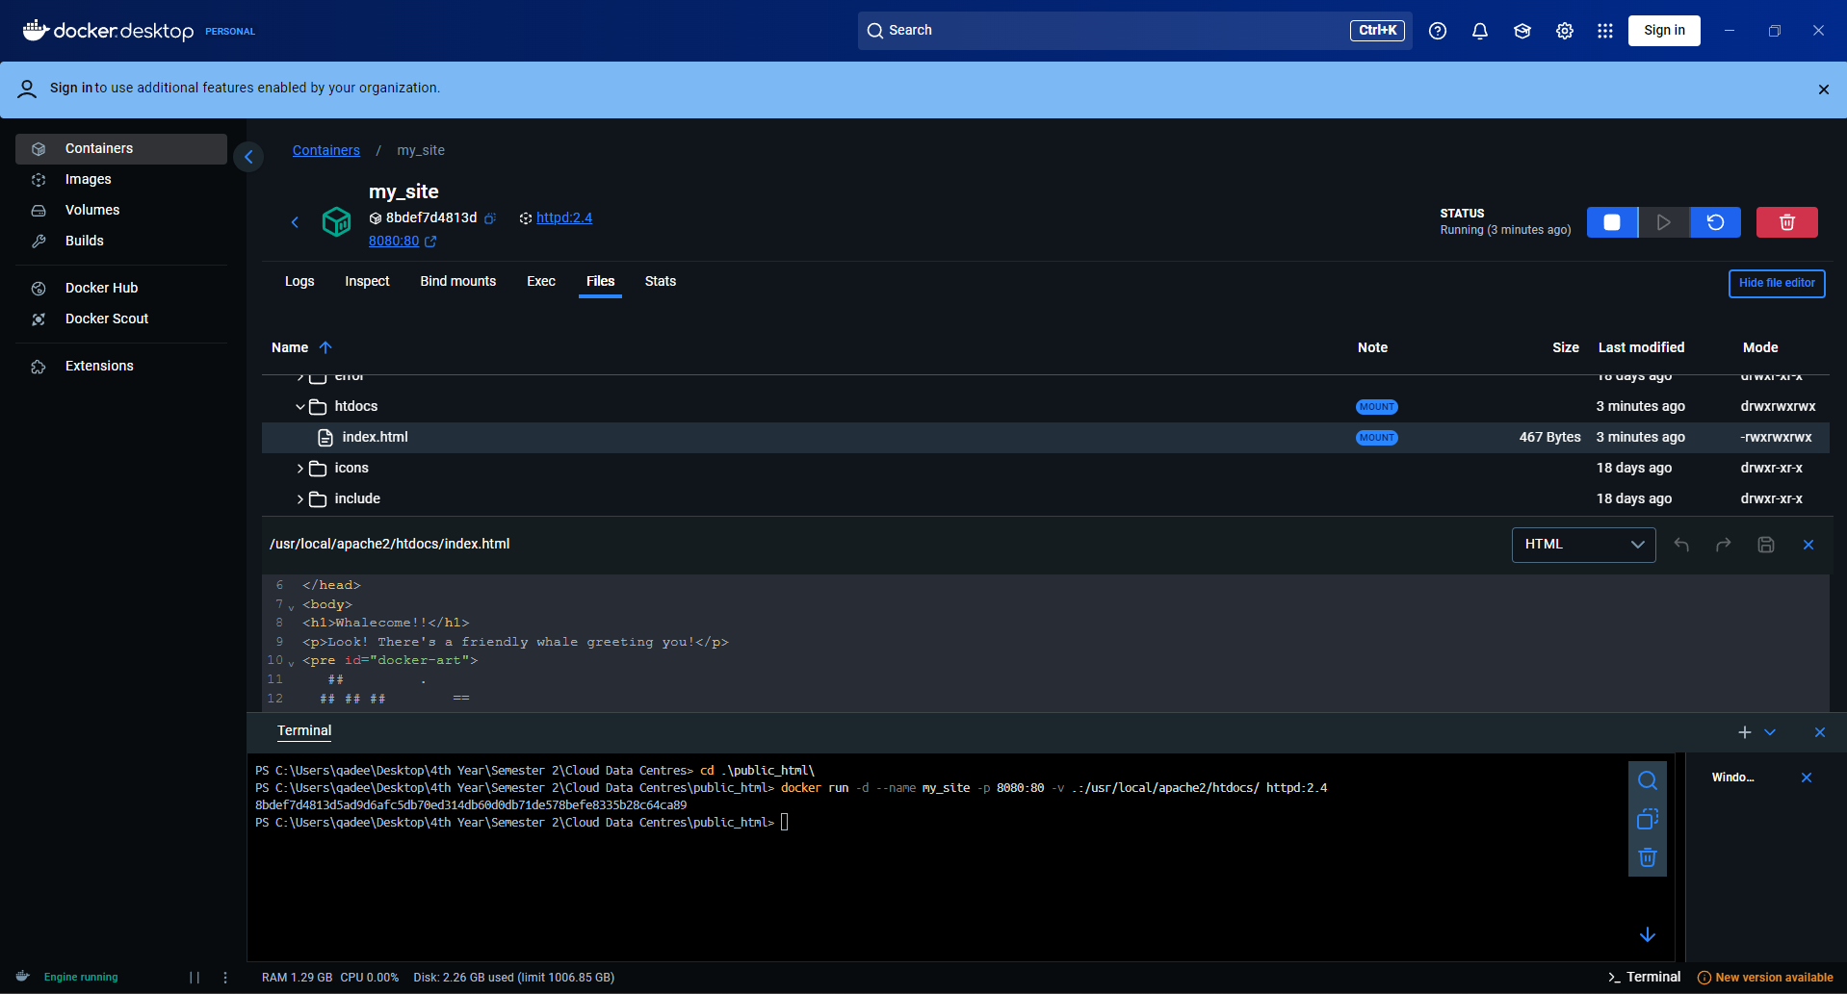

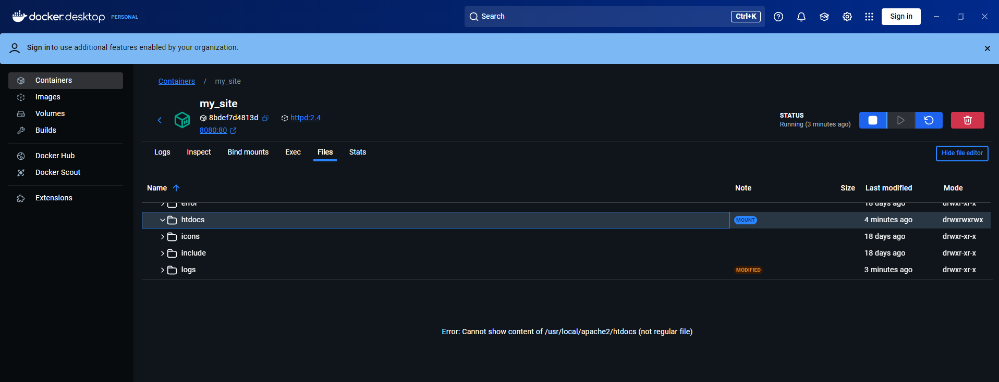

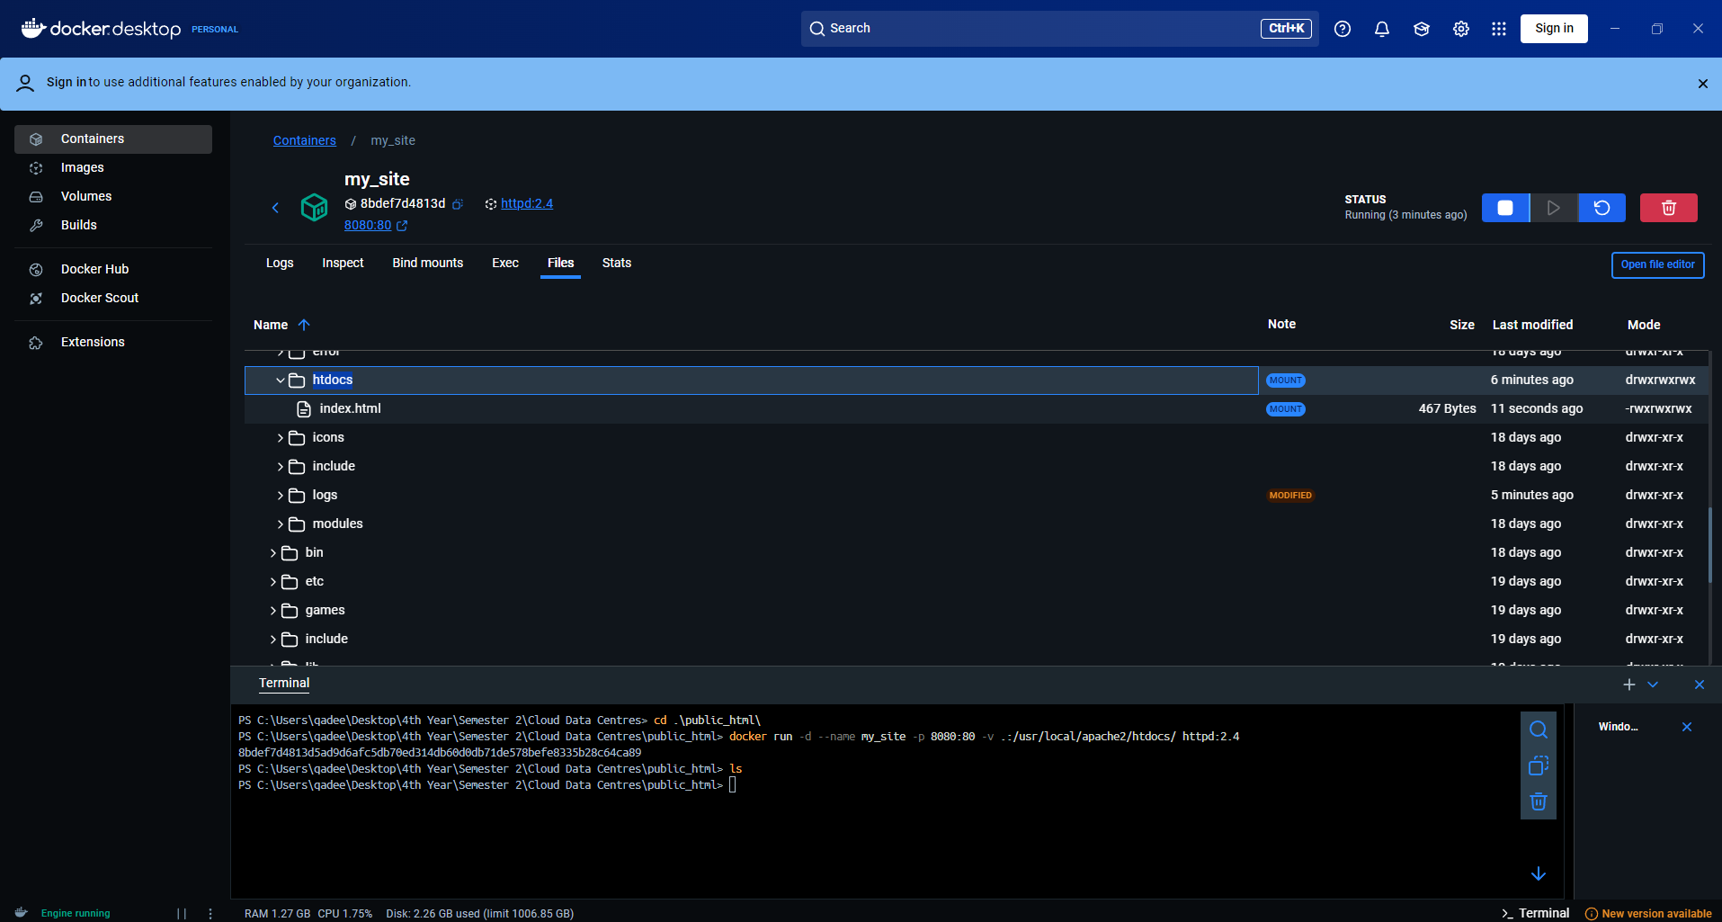

#### **Stop your container**

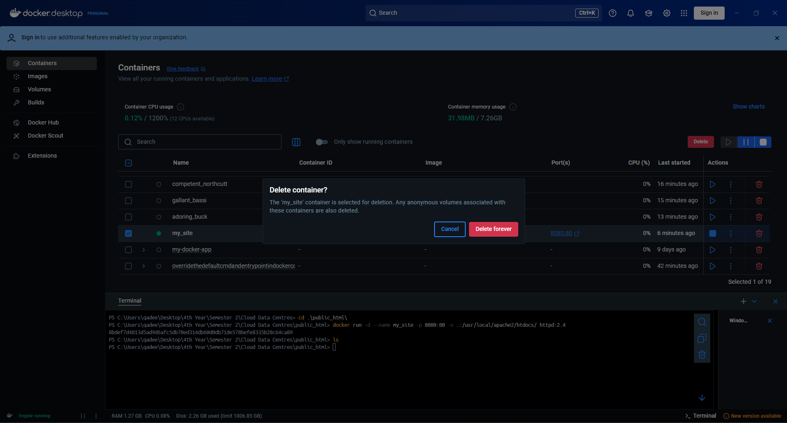

## **Multi-container applications**

### **Try it out**

#### **Set up**

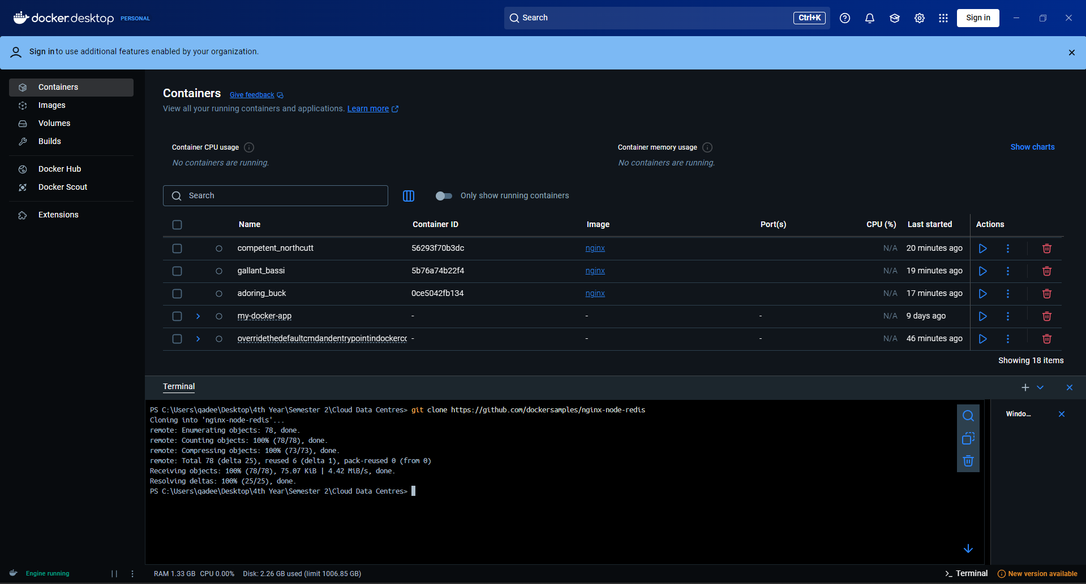

#### **Build the image**

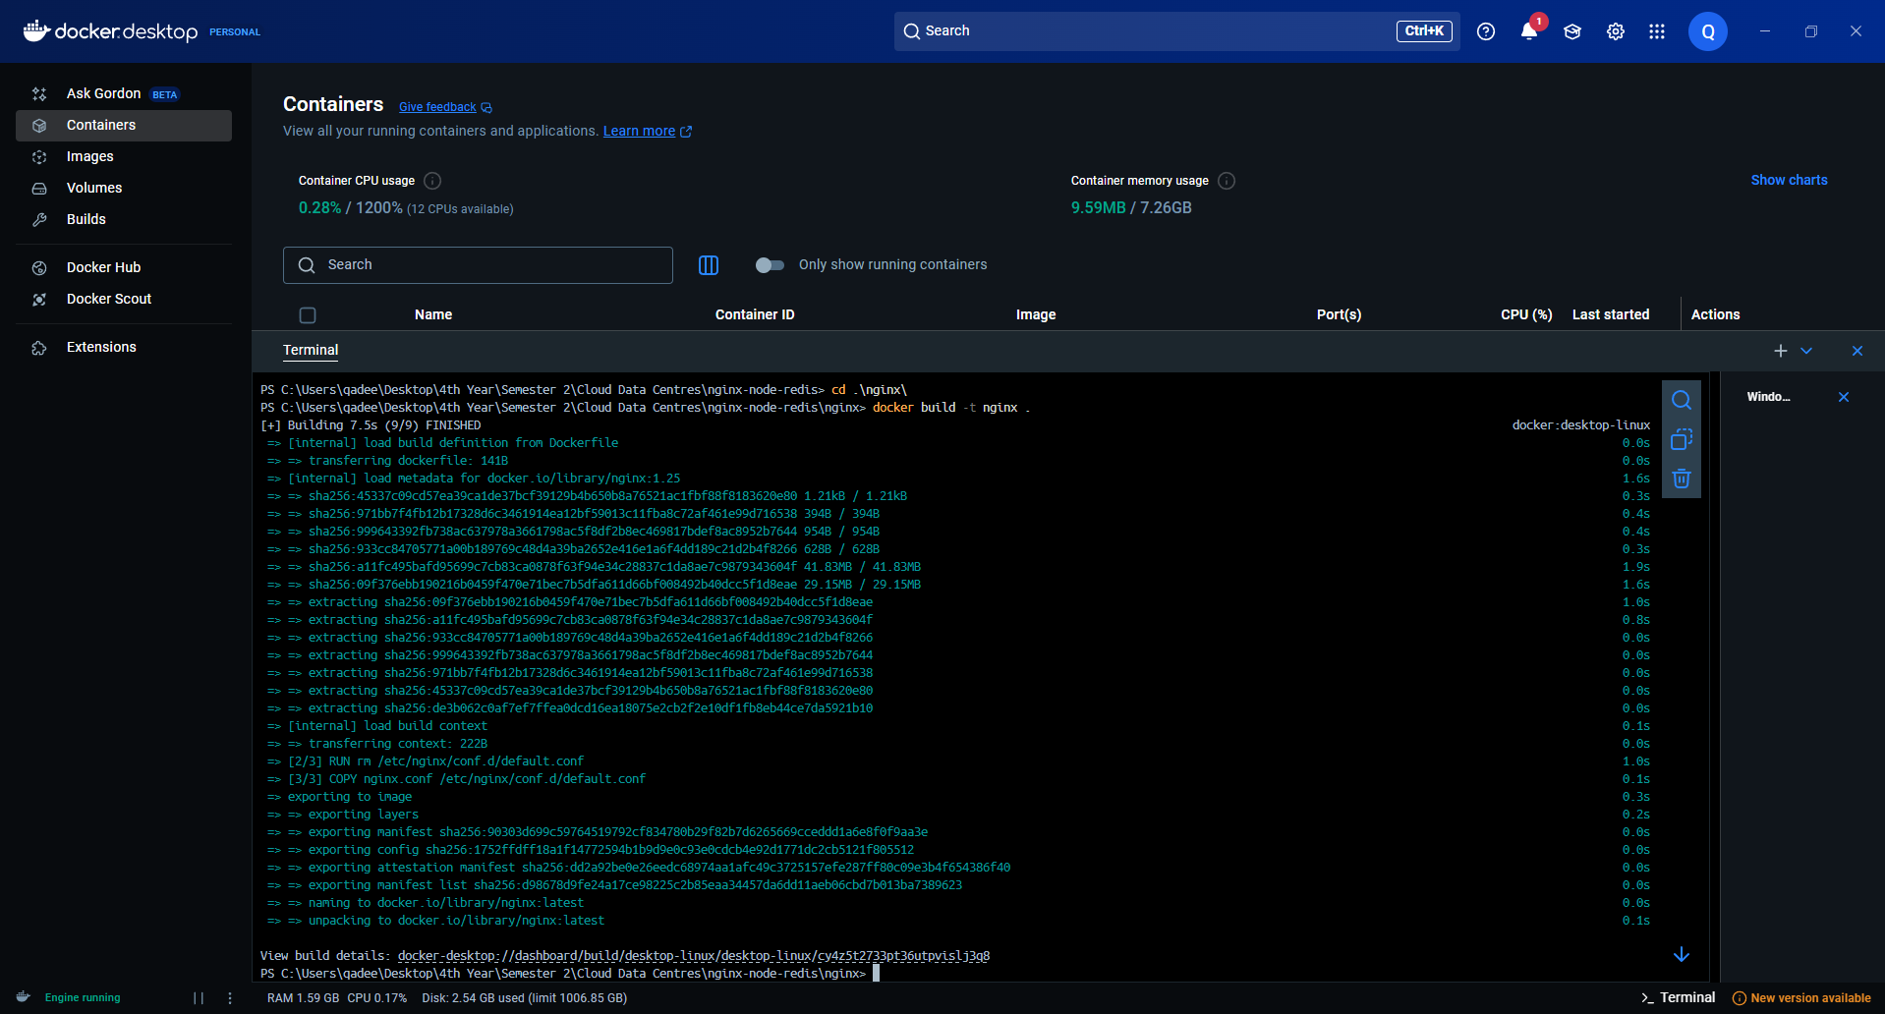

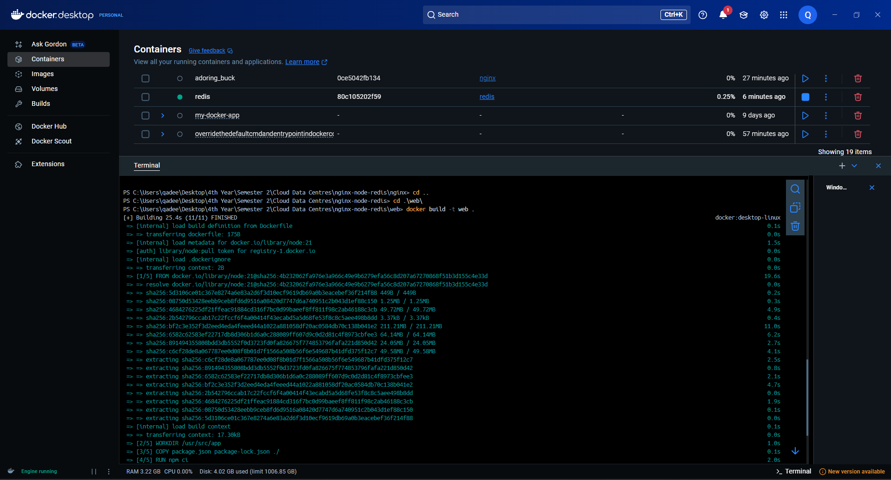

#### **Run the container**

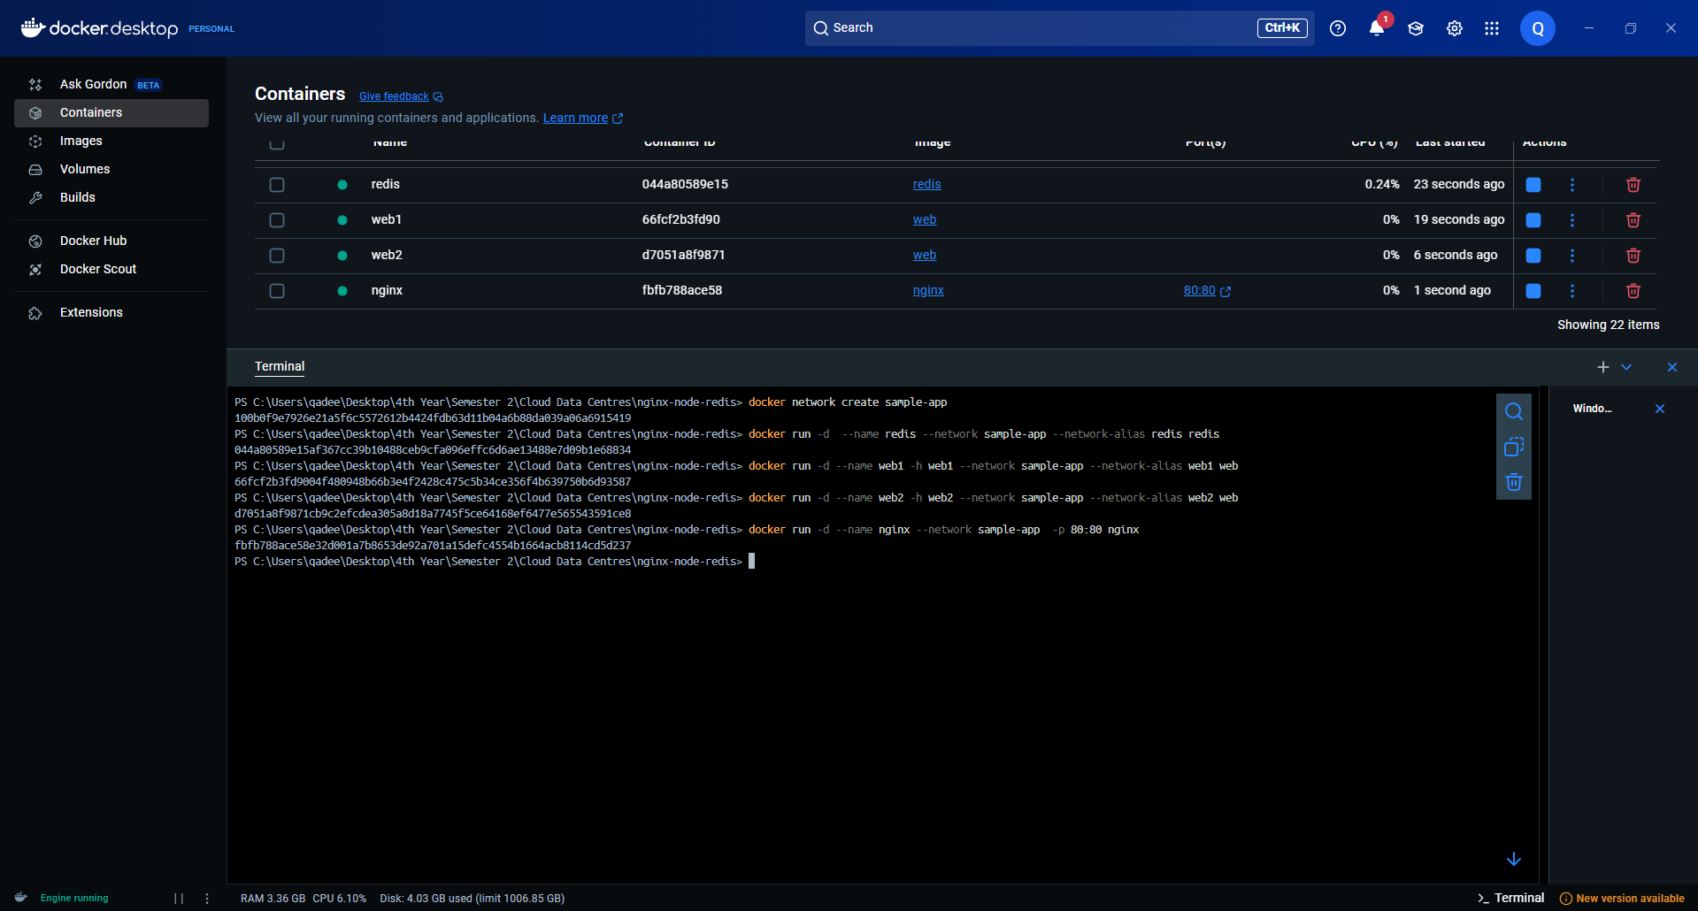

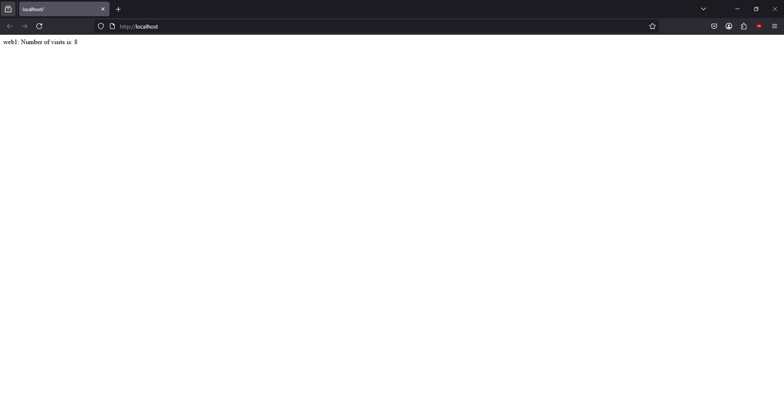

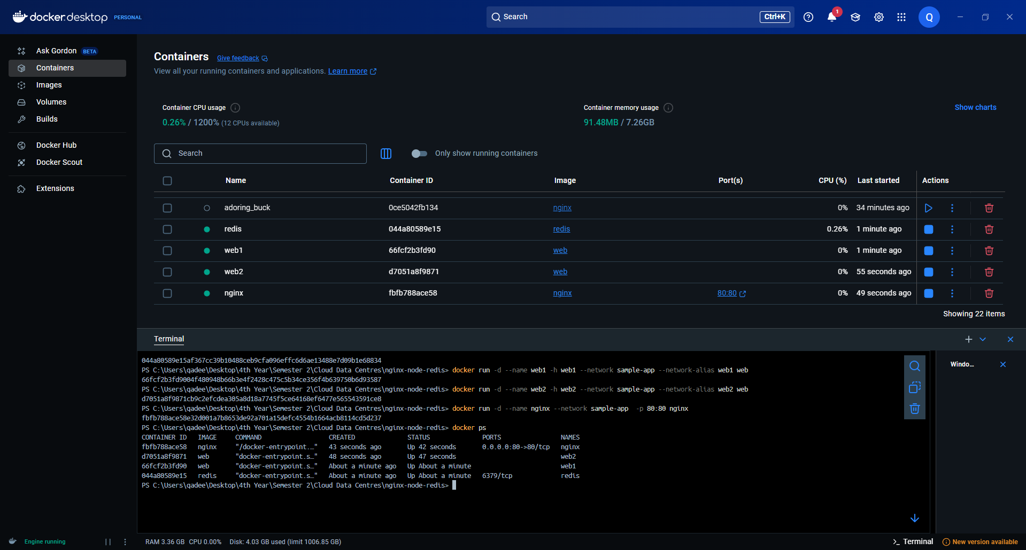

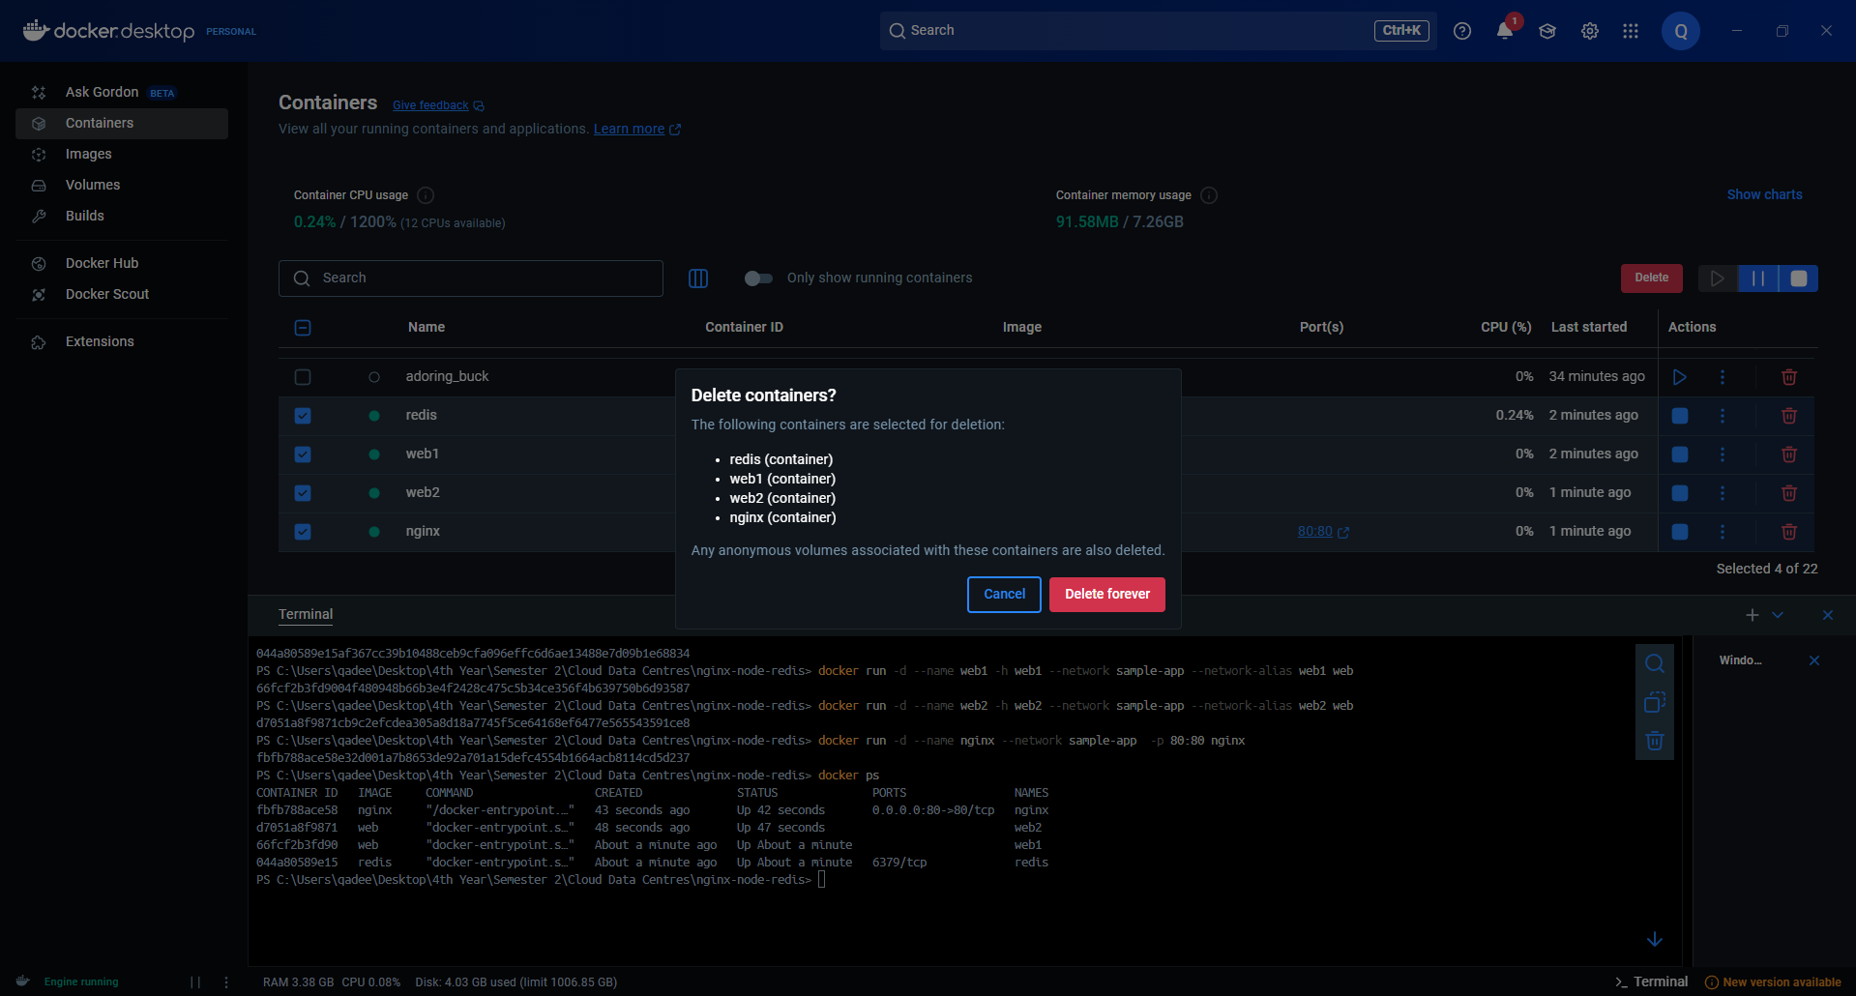

#### **Simplify the deployment using Docker Compose**

